BIOCONVERSION AND BIOAUGMENTATION OF SOYBEAN MEAL FOR SUSTAINABLE BIOFERTILIZER PRODUCTION
Dr. Ademola Hammed^{1,**}, Dr. Ewumbua Monono ^{1,*} & Dr. Niloy Chandra^{1,*}
¹Agricultural and Biosystems Engineering, North Dakota State University.
**Principal, *Co-principal investigator
Research Overview:
Farmers heavily depend on ammonia containing fertilizer to improve crop yield and profitability. However, ammonia production is challenged by huge energy demand, release of 2% of global CO₂ and political instability. A 25% nitrogen fertilizer produced by Russia is currently off market due to the ongoing Russia-Ukraine war and Russia has reduced gas supply to Europe that further caused 60% reduction of nitrogen fertilizer production. Second, soybean oil is used as the major feedstock for biodiesel and will increase with biodiesel production upsurge in the United State. As a bioproduct of soybean oil production, soybean meal will become abundant calling for the development of alternative use technologies for value added products like biological ammonia (biofertilizer). The current research aims to upscale and improve the process via stepwise or hybrid processing methods (bioconversion and bioaugmentation). The bioconversion scale-up of our existing technology will focus on using microbes to convert soybean meal to biological ammonia while the bioaugmentation will focus on using different microbes to sequester air nitrogen to biological ammonia.
Objectives:
- To develop an upscaled bioconversion of soy meal biological ammonia for biofertilizer production.
- To develop an enhanced nitrogen/protein bioaugmentation of soy meal biological ammonia for biofertilizer production.
Completed Work: Deliverables and/or Milestones:
The first objective has been completed, and the following milestones have been achieved
- Knowledge of enzyme consortiums required to improve soybean bioprocessing.
- Information about potential new use of soybean meal for bio-ammonia production.
Progress of Work and Results to Date:
Protein extraction: Soybean meal flour of particle size 0.425 – 1 mm was soaked in 0.5% ammonium hydroxide (NH₄OH) at 1:10 sample-to-solvent and incubated at 55º C with continuous shaking for 12 h. The mixture was centrifuged at 10, 000 ´ g, 25ºC for 10 min. The supernatant was collected, and its pH was adjusted to protein isoelectric point (4.5 – 5). The protein isolate was sedimented overnight, the sediment was retrieved and washed (´2 dH₂O) and dried at 60ºC for 24 h. The extracted soybean meal protein isolate (SMPI) was hydrolyzed according to the protocol used by (Cui et al., 2013).
Soymeal protein hydrolysis fermentation: The extracted SMPI was hydrolyzed according to Adeniyi et al., (2023). Approximately 4 g of SMPI were dispersed in 100 ml of distilled water. The solution's pH was then modified to 2.0 using 1 M HCl. After this pH adjustment, the solution underwent a 30-minute incubation in a water bath at 37 ℃, followed by the addition of pepsin (0.3% w/w). The SMPI–enzyme mixture was further incubated in a water bath for 10 h. Subsequently, the pH was readjusted to 7.0 using a 2 M NaOH solution to stop the hydrolysis process. Following this, the enzyme digests underwent centrifugation at 5000 g for 3 minutes to remove any insoluble residues. The resulting supernatant was then appropriately diluted with a basal medium to generate the hydrolysates for use in subsequent fermentation experiments.
HAB enrichment: Approximately 40 ml of rumen fluid containing a consortium of microorganisms was collected from three fistulated dairy cows at North Dakota State University's Animal Nutrition and Physiology Center. The fluid, initially stored in 50 ml plastic screw-cap tubes, was promptly moved into an incubation chamber at 39°C to sustain the microbial ruminal environment. The HAB isolation and enrichment medium was prepared using the method outlined by Adeniyi et al., (2023). The sediment in the ruminal content was allowed to settle, and the resulting ruminal fluid was diluted at a ratio of 1:100 to achieve an optical density (OD) of approximately 0.05. This diluted fluid was then introduced into a 1.5% (w/v) casamino acid medium (casamino enrichment). The enrichment culture, prepared in a BACTRONEZ Anaerobic Chamber (Sheldon Manufacturing Inc.), was incubated in a shaker at 39°C and 130 rpm. To maintain a robust HAB population, the culture was regularly transferred to a fresh Casamino-containing medium every 24 h.
SMPI fermentation and ammonia production: The Fermentation medium employed consisted (g/L) of: K₂HPO₄, 0.292; KH₂PO₄, 0.292; Na₂SO₄, 0.480; NaCl, 0.10; CaCl.2H₂O, 0.064; Na₂CO₃, 4.0 and yeast extract, 0.50, with initial adjusted pH of 6.5 – 6.6 (Attwood and Reilly, 1995). 250 ml Erlenmeyer flasks containing about 100 ml mixture of SMPI hydrolysate and fermentation media were inoculated with 1 ml of inoculant and incubated at 39 ºC, 130 rpm and different ranges (24 – 168 h) to investigate substrates utilization by ruminal HAB for microbial growth and ammonia production. Prior to inoculation, SMPI hydrolysate-fermentation media mixture was autoclaved at 120 ℃ for 1 h. At 24 h fermentation intervals, samples were taken and filtered with Whatman qualitative filter paper, Grade 1 (Whatman 1001-045 Article No. 28413909).
Microbial growth profile : A 2 ml sample was collected in the BACTRONEZ Anaerobic Chamber, Sheldon Manufacturing Inc, and filtered as required before measuring the optical density at 600 nm in UV-Vis Spectrophotometer (Varian. Cary 4000). The effect of pH and alkalinity was further assessed.
Ammonia Quantification: The quantity of ammonia produced in each fermentation treatment was determined by colorimetric assay using the Nitrogen-Ammonia reagent kit (Hach Company, Catalog No. 50-199-6332). The protocol for the Nitrogen-Ammonia reagent kit was followed and quantities of ammonia in mg/L were measured in the DR3900 laboratory spectrophotometer with the NH₃-N program.
One-Factor-At-A-Time (OFAT) Studies and Screening of Media Components
OFAT studies and screening of media components were carried out to evaluate how different salt components affect the production of biological ammonia. This research specifically investigated the effects of salts derived from different sources, including sodium, calcium, phosphate, and other mineral salts, on biological ammonia production. The study used a predetermined media composition based on the method outlined by Attwood and Reilly, (1995). Throughout the OFAT experiment, the concentration of salts under investigation were varied, while the concentrations of other salts were held constant. During the OFAT experiment, while varying the concentration of the salt of interest, the concentrations of other salts were kept constant. Various concentrations of individual salt components within a predetermined range were utilized as outlined below: K₂HPO₄ (0.00292 – 0.292 g/100mL), KH₂PO₄ (0.00292 – 0.292 g/100mL), Na₂SO₄ (0.0048 – 0.48 g/100mL), NaCl (0.001 – 0.1 g/100mL) CaCl₂.2H₂O (0.00064– 0.064 g/100mL) Na₂CO₃ (0.04 – 4.0 g/100mL), Yeast extract (0.005 – 0.5 g/100mL) and SMPI (2.5 – 25 %). Following the determination of optimal ammonia production from OFAT, some salts were selected for subsequent optimization.

Results
Extraction optimization
Soybean protein extraction was optimized at different processing conditions. As shown in Fig. 1, interactions between solvent ratio and extraction time caused an increase in protein extraction yield, resulting in a maximum protein yield of about 65% at a time and solvent ratio of 12 h and 1:10 w/v respectively. However, further increase in time and solvent ratio after reaching the optimum caused a corresponding decrease in protein yield. Also, variations in NH₄OH concentration and solvent ratio showed that protein yield was highest when NH₄OH concentration was at 0.5 % (result not shown). Further increase in extraction time doesn’t have much effect on protein extraction yield in the selected range of study.
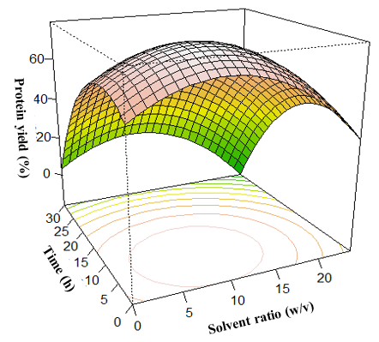
Fig. 1. Effect of extraction time and solvent ratio on protein yield
Effect of pH and alkalinity on HAB growth
The study aims to explore alkaline pH levels in the fermentation process designed to produce ammonia, which naturally elevates the medium's pH. While alkaline pH can enhance protein solubility and bioavailability, its impact on the proliferation of highly ammonia-producing bacteria (HAB) remains unknown. The investigation focuses on determining the alkalinity strength and optimal pH for microbes during soy protein fermentation at varying pH levels. The experiment monitors HAB growth profiles at different pH levels (7, 8, 9, 10, and 11) over various time intervals (12 to 168 hours) to understand the effect of pH on HAB growth and identify the optimum fermentation pH. Findings indicate that microbial growth differs at various pH levels. As anticipated, microbial growth curves displayed sigmoidal patterns at all pH values, showcasing distinct optical densities and patterns during their exponential, stationary, and death phases (McKellar and Lu, 2004) (Fig. 2).
Following the initial 12-h lag phase, a significant growth transition marks the beginning of the log phase. In this phase, there is a rapid acceleration in the growth rate, resulting in exponential proliferation of the microbial population, characterized by high reproduction rates (Kim et al., 2011). Fig. 2 illustrates that microbial growth at pH 7 provides a particularly favorable environment for robust proliferation during the log phase, indicating that pH 7 enhances exponential population growth.
After the log phase, the stationary phase follows. The length of the stationary phase is closely linked to the survival and progression of cells (Jaishankar and Srivastava, 2017). Notably, at pH 7, the stationary phase growth pattern is longer, spanning from 36 to 144 h. This extended stationary phase at pH 7 provides stability and support for the HAB population to utilize cellular reserves while sustaining their persistence. The overall observation indicates that pH 7 is optimal for HAB proliferation during soymeal protein fermentation.

Fig 2. HAB microbial growth curve at varying pH (7-11) and time (12 – 168 h)
Effects of varying substrate concentration for biological ammonia production
In this research, soy meal protein isolate (SMPI) was chosen as the primary substrate. To determine the most effective substrate level for enhancing biological ammonia production during HAB fermentation, concentrations of SMPI ranging from 2.5% to 20% were subjected to a 72h fermentation process, representing a pioneering exploration of the impact of different SMPI concentrations on biological ammonia production. The results indicate a direct relationship between substrate concentration and biological ammonia concentration. As shown in Fig. 3, ammonia production increased steadily as the substrate concentration rose from 2.5% to 10%, reaching its peak at approximately 3500 mg/L with a 10% substrate concentration. However, beyond this point, there was a gradual decline in ammonia production. The observed decrease in ammonia concentration may be attributed to the accumulation of toxic byproducts during fermentation, exerting inhibitory effects on product formation.
Effects of varying inoculum concentration for biological ammonia production
Different concentrations of inoculum (1%, 2.5%, 5%, and 10%) were introduced into the media and observed at various fermentation intervals (0, 24, 48, 72, 120, and 168 h). Fig. 4. shows the impact of inoculum concentration on biological ammonia production over time. In the initial 24 h, there was a direct correlation between inoculum size and ammonia production, with larger inoculum sizes resulting in increased ammonia output. After 24 h, ammonia production declined temporarily before resuming after 48 h. Except for the 2.5% inoculum, all sizes reached peak performance at 72 h, after which ammonia production decreased.

Fig. 3: Effect of substrate concentration on biological ammonia production at 72 h

Fig. 4: Effect of inoculum concentration and time on biological ammonia production
The highest biological ammonia concentration, approximately 8,805 mg/L, occurred with a 10% inoculum at 72 h, aligning with the recommended 5–10% inoculum size range.
OFAT Screening of Media Components
Effect of phosphate sources
OFAT studies were conducted to assess the individual impact of media components on ammonia yield, with a focus on phosphates. The study specifically examined the effect of phosphate sources, primarily K₂HPO₄ and KH₂PO₄, on biological ammonia production. Varying amounts of these phosphates were tested individually while keeping other basal media salts constant. As shown in Fig. 5 (a and b), the results indicated a rapid increase in biological ammonia production at a concentration of 0.0292 g/100mL, resulting in yields of 2,985 mg/L for K₂HPO₄ and 2,715 mg/L for KH₂PO₄. However, further increase in phosphate led to a reduction in ammonia production, potentially due to enzyme inhibition caused by the accumulation of inorganic phosphate in the fermentation media.

a

Fig. 5: Ammonia yield at different variations of phosphate salts a: K₂HPO₄; b: KH₂PO₄

Effect of Sulphate Sources
Sulfur is essential in microbial metabolism, sourced primarily from sulfate during fermentation. Microorganisms convert sulfate to sulfide in complex pathways. Sulfate sources have a dual role, acting as sulfur reserves and influencing the fermentation medium's ionic composition. In the present study, Na₂SO₄ was utilized as the sulfate source. The effect of Na₂SO₄ concentration on biological ammonia production is shown in Fig. 6.

Fig. 6: Ammonia yield at different variations of Na₂SO₄

The findings reveal a substantial rise in biological ammonia concentration from 2,060 mg/L at 0.0096 g/100mL to 4,000 mg/L at 0.048 g/100mL, followed by a sharp decline at 0.24 g/100mL. Increasing Na₂SO₄ concentration from 0.24 g/100mL to 0.48 g/100mL resulted in a decrease in biological ammonia production from 4,000 mg/L to 2,820 mg/L. OFAT results highlighted that the variation in Na₂SO₄ concentration at 0.48 g/100mL led to a high biological ammonia output, prompting further optimization. These findings emphasize the significant impact of Na₂SO₄ concentration on biological ammonia production. Therefore, optimizing Na₂SO₄ concentration has the potential to enhance overall biological ammonia production.
Optimization of media salts
After conducting the One-Factor-At-a-Time (OFAT) study, the selected salts (K₂HPO₄, KH₂PO₄, Na₂SO₄) and SMPI were further optimized for biological ammonia production through 30 experimental runs. To determine the optimum yield, a response surface methodology (RSM) and central composite design (CCD) approach was used. A 3-D response surface was utilized as graphical representations of the regression equation. Each contour graph generated specifically depicts the production of biological ammonia from two distinct combinations of fixed independent variables, while holding the other two variables at their respective zero levels. Three typical 3-D response surface plots are shown in Fig. 7.

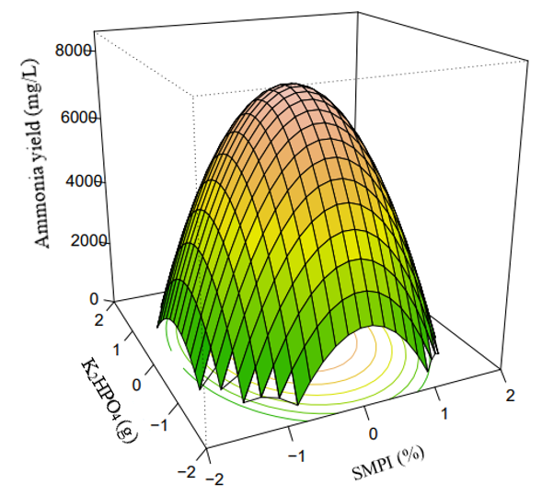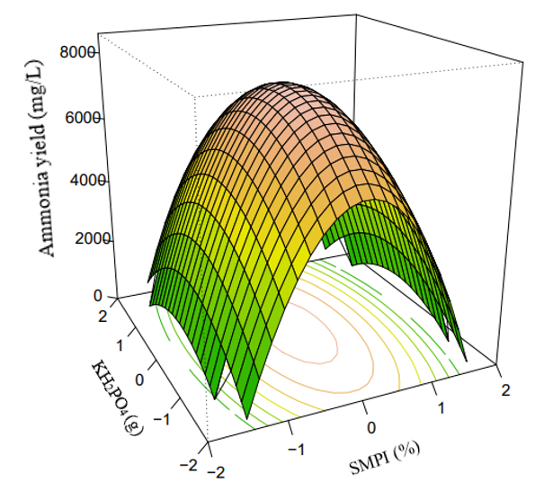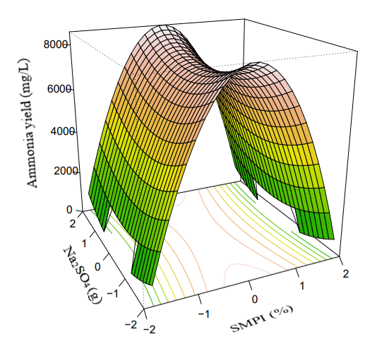
Fig. 7. 3-D Surface Plots of biological ammonia production for the interaction between (a) K₂HPO₄ and SMPI, (b) KH₂PO₄ and SMPI and (c) Na₂SO₄ and SMPI, at zero levels of other components.

Fig. 7a illustrates the impact of varying concentrations of K₂HPO₄ (0.00292 – 0.292 g/100mL) and SMPI (1:5 – 1:15) on biological ammonia production, with Na₂SO₄ and KH₂PO₄ held constant at 0.048 g/100mL and 0.0292 g/100mL, respectively. As the concentrations of K₂HPO₄ and SMPI increased, biological ammonia production rose, reaching a peak at the midpoint, and then decreased. Similarly, Fig. 7b and Fig. 7c depict the effects of varying KH₂PO₄ (0.00292 – 0.292 g/100mL) and SMPI (1:5 – 1:15), and Na₂SO₄ (0.0048 – 0.48 g/100mL) and SMPI (1:5 - 1:15), respectively, on biological ammonia production under constant conditions. The overall optimization study identified the optimal conditions for achieving a biological ammonia yield of ~7,200 mg/L (7.2 g/L), with optimized concentrations of 0.0492 g/100mL K₂HPO₄, 0.0492 g/100mL KH₂PO₄, 0.064 g/100mL Na₂SO₄, and 10% SMPI. This yield surpasses previously reported yields, establishing a new record as the highest reported to date. The substantial improvement is attributed to anaerobic fermentation of HAB with hydrolyzed SMPI, a nitrogen-rich resource with minimal inhibitory effects from foreign food components such as glucose.

Work to be Completed:
- The current focus on improving soy meal biological ammonia production via nitrogen fixing bacteria to bio-augment nitrogen/protein needed for biofertilizer production.
Other relevant information:
- Potential barriers to achieving objectives,
  - One barrier we face is overcoming the phase barrier between air and water during the nitrogen fixation experiment.
- Risk mitigation strategies
  - We will be adopting a fixed bed reactor design that has been reported to improve gas-liquid contact.
- Breakthroughs.
  - We have successfully improved the yield of bio-ammonia and showed scalability potential.
Summary:
This study used a unique method to replicate rumen microbial fermentation in vitro for biological ammonia production. The process involved fermenting soymeal protein hydrolysate using a consortium of HAB over a 72-h time, resulting in the highest bio-ammonium yield reaching 7.5 g/L. The application of Response Surface Methodology (RSM) proved remarkably effective in optimizing biological ammonia production. The results showed that with the combination of the media formulation developed –K₂HPO₄ (0.049 g/100mL), KH₂PO₄ (0.049 g/100mL), Na₂SO4 (0.064 g/100mL), NaCl (0.1 g/100mL), CaCl₂.2H₂O (0.064 g/100mL), Na₂CO₃ (4.0 g/100mL), yeast extract (0.5 g/100mL), and SMPI (10%)– the observed ammonia yield was approximately 80 % higher than in previous studies, highlighting the potential of biological ammonia production as a sustainable and efficient alternative to the conventional Haber process.
References
Adeniyi, A., Bello, I., Mukaila, T., Monono, E., Hammed, A. (2023). Developing rumen mimicry process for biological ammonia synthesis. Bioprocess and Biosystems Engineering, 1–10.
Attwood, G. T., Reilly, K. (1995). Identification of proteolytic rumen bacteria isolated from New Zealand cattle. Journal of Applied Bacteriology, 79(1), 22–29.
Cui, C., Zhao, M., Yuan, B., Zhang, Y., Ren, J. (2013). Effect of pH and pepsin limited hydrolysis on the structure and functional properties of soybean protein hydrolysates. Journal of Food Science, 78(12). https://doi.org/10.1111/1750-3841.12309
Jaishankar, J., Srivastava, P. (2017). Molecular basis of stationary phase survival and applications. Frontiers in Microbiology, 8, 2000.
Kim, D.-H., Kim, S.-H., Jung, K.-W., Kim, M.-S., Shin, H.-S. (2011). Effect of initial pH independent of operational pH on hydrogen fermentation of food waste. Bioresource Technology, 102(18), 8646–8652.
McKellar, R. C., Lu, X. (2004). Primary models. Modeling Microbial Responses in Food, 21–62.

