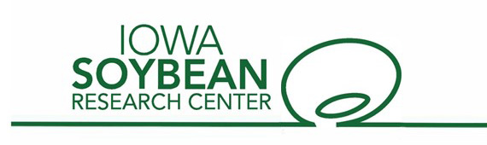

ISRC Project Update

- About the project
  - Project Title: Enhancing implementation and adoption of non-chemical tactics for integrated weed management in soybean
  - Lead PI: Prashant Jha, Dept. of Agronomy
- Co-PIs: None
  - Projects year(s): 2021-2023
  - Total amount of funding: $100,000
  - Leveraged/Additional Funding, including federal or private organizations: Additional funding from USDA-NIFA grants totaling ~$620,000 were leveraged with multi-state (IA, AR, KS, IL) collaborations.

- Project Summary

  - Objectives:
    - Integrate ecologically-based integrated weed management (IWM) strategies, namely, cover crop and harvest weed seed control (HWSC), for managing herbicide-resistant weed seed banks in soybean.
    - Quantify the economic benefits and risks of adopting a diversified IWM program to mitigate herbicide resistance for development of decision support tools (DSTs) for soybean producers.
  - Deliverables: Soybean producers in Iowa have demonstrated increasing interest in the two new harvest weed seed control technologies, namely chaff lining and weed seed destructor to manage herbicide-resistant weeds on their farm fields.

    - A Redekop Weed Seed Destructor attached to a JD S680 combine was demonstrated at the Farm Progress Show in Boone, IA in 2022, participants: >500
    - Information and data from harvest weed seed control technology in soybean was presented at the ICM conference, statewide Crop Advantage Series meetings, and industry-sponsored events held in Iowa in 2021/2022, total participants ~5000.
    - The project concept and results were presented by the PI at North Central Weed Science Society and Weed Science Society of America annual meetings held in 2022/2023.
    - ICM blog articles on IWM strategies in soybean were posted.

  - Benefit to Soybean Farmers: This project seeks to increase successful adoption of IWM strategies for mitigating herbicide resistance as a component of sustainable soybean production in Iowa and the Midwestern region. The involvement of the Iowa producers in this project has proven to be an effective mechanism to leverage partnerships and enhance the implementation and adoption of cover crops and harvest weed seed control technology in Iowa.
  - A minimum of 30% of the corn and soybean farmers who receive information from this on-farm research are expected to integrate HWSC methods (chaff lining, seed destructor) and cover crops as effective IWM strategies for herbicide-resistant weed management.
  - Recommendations based on this research will be incorporated into the “Take Action” outreach materials and distributed to over 20 meetings or field days annually to almost 500 soybean growers.
  - Web-based videos on practical weed management tips generated from this research will be viewed by ~200 weed management practitioners per year.
  - These metrics will be measured by conducting follow up grower surveys in Iowa through active participation of ISU ANR Crops Team, Extension Field Agronomists, and ISA On-Farm Network.
  - Augmenting current weed control practices with sustainable IWM-based approaches highlighted in this project will greatly improve the profitability and sustainability of soybean-based the cropping systems of Iowa, currently threatened by multiple herbicide-resistant pigweeds. Ultimately this project will reduce potential environmental impacts associated with increased pesticide use.

- Progress Update (what steps have been taken/initial set up or early findings): Long-term field experiments were initiated at ISU Research Farm and across three grower fields in Iowa in fall of 2021, with planting of cereal rye cover crop. The field sites had a natural uniform infestation of glyphosate-resistant waterhemp. The entire trial area at each study site was intensively soil sampled (10-cm depth) prior to initiation of the study in the fall of 2021, and exhaustive germination procedures were used to estimate initial pigweed density in the soil seed bank. A strip-split-plot randomized complete block design with four replications was used. The cereal rye cover crop was terminated (anthesis stage) after soybean planting in May of 2022. Herbicide treatments (PRE only vs. PRE followed by POST) were implemented in soybean in 2022 growing season. Data on pigweed emergence was monitored in four 0.5 m² quadrats at a biweekly basis with a final density count before soybean harvest. Data on waterhemp seed production/retention at soybean harvest was recorded in each plot. The harvest weed seed control (seed destructor on vs. off) was implemented in fall of 2022.
Preliminary results on efficacy of harvest weed seed control (HWSC): 75-80% of waterhemp seeds are retained by plants at the typical harvest dates of soybean in Iowa. Header loss accounted for 30% of waterhemp seed losses at soybean harvest and additional 10% loss could occur at the grain tank and from seeds escaping through the combine thresher (chopper). More than 90% of waterhemp seeds that entered the combine and passed through the seed destructor unit had moderate to severe physical damage and were non-viable.
Biological data on waterhemp emergence, percent control, and end-season seed bank decline as influenced by cereal rye cover crop by herbicide by harvest weed seed control interactions (implemented in 2022) will be collected in soybean in 2023. Results will be analyzed and presented in the final report.

- Supporting attachments:
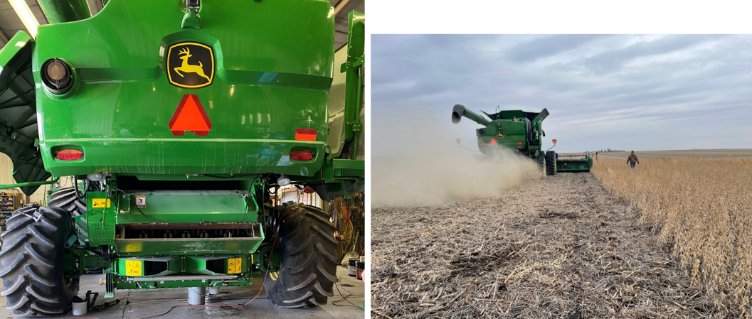
- Photos/graphs/other graphics

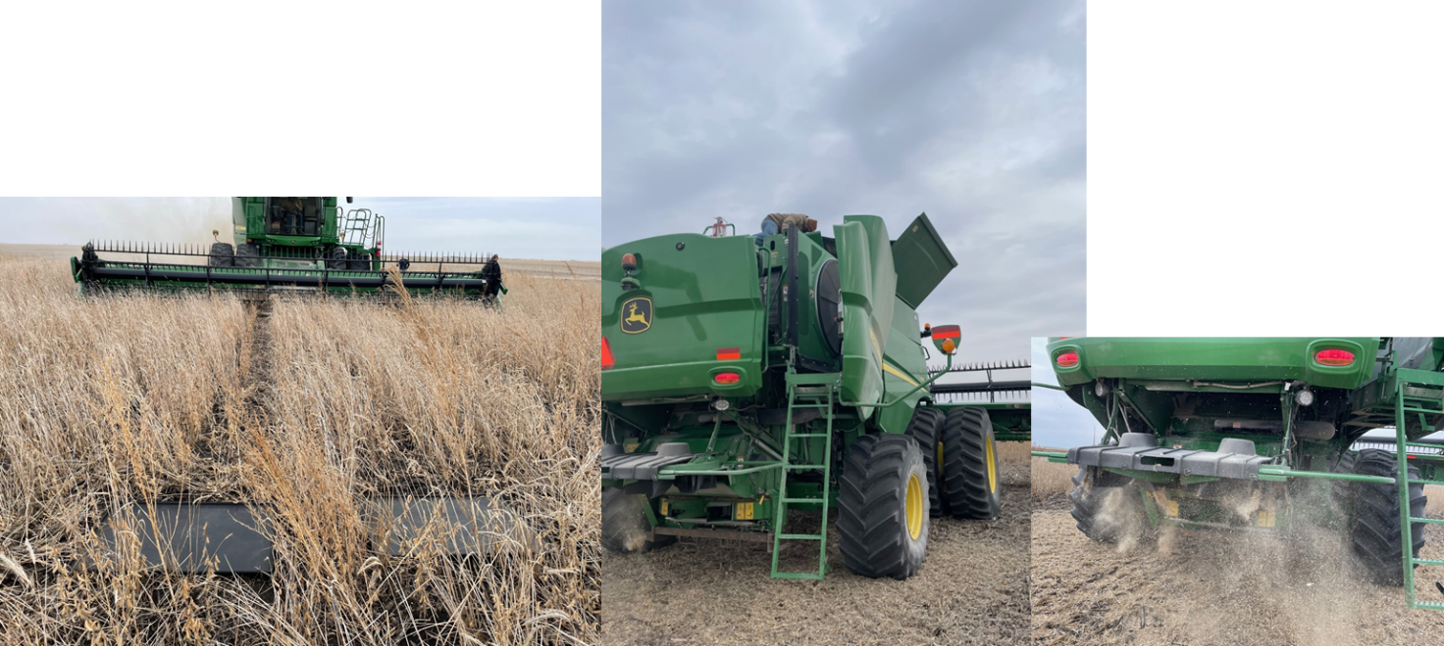
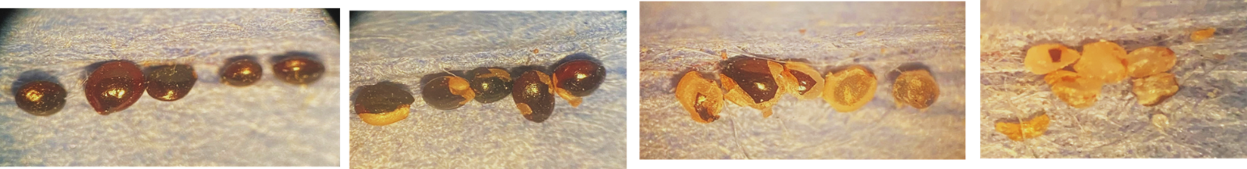
Measuring header, grain tank, and thresher loss of waterhemp seeds, Dayton, IA 2022
Different levels of physical damage of pigweed seeds after passing through the Redekop seed destructor (high impact mill)

