Enhancing Profitability of Soybean Production and Soil Health through Livestock Integration
Joshua Wianecki¹, Miranda Meehan¹, Zachary Carlson¹, Lindsay Malone², Kevin Sedivec^{2,3}, Colin Tobin⁴, Michael Ostlie⁴
¹Department of Animal Sciences, North Dakota State University, Fargo ND. ²School of Natural Resource Sciences, North Dakota State University, Fargo ND. ³Central Grasslands Research Extension Center, Streeter ND. ⁴Carrington Research Extension Center, Carrington ND.

Objectives:
The objective of this study is to enhance the profitability of soybean production and soil health through livestock integration and cover crop management. This study utilizes livestock integration and cover crop management on winter rye cover crops through dual season (fall and spring) grazing, spring grazing, no grazing, or no winter rye cover crop. Soil physical, chemical, and biological health; soybean production; livestock performance, and economic effects will be evaluated.

Project Update
Completed Work:
Locations at the Central Grasslands Research Extension Center (CGREC) and Carrington Research Extension Center (CREC) were selected for a two-year study. Each field was divided into nine pastures and randomly assigned one of four treatments: dual season (fall and spring) grazing (DG), spring grazing (SG), no grazing (NG) or no winter rye cover crop (NR). The NG plots were split to include NR treatments.
Forage samples were collected by clipping six 0.25m² quadrats prior to and post-grazing. Absolute ground cover was also evaluated during clipping by determining percentage of bare ground, live winter rye, crop residue, and annual weed cover. Forage yield was estimated to determine grazing duration. Forage samples were collected and submitted to the NDSU Nutrition Lab for nutrient analysis of crude protein (CP), neutral detergent fiber (NDF) acid detergent fiber (ADF), and in vitro dry matter digestibility (IVDMD).
Grazing length was determined by estimated forage yield as well as daily visual pasture inspection. During the fall grazing period, four bred heifers at CGREC and five bred heifers at CREC were turned out onto each DG treatment. During the spring grazing period, nine open heifers at CGREC and six open heifers at CREC were turned out onto each DG and SG treatment. During the spring grazing period a control group of animals was fed within a dry lot system. Ration for the dry lot cattle was formulated to maintain approximately 0.68kg/day rate of gain. Cattle performance was evaluated through average daily gain (ADG) and body condition score (BCS) pre- and post-grazing. Cattle weights were recorded on two consecutive days following feed restriction pre- and post-grazing. Body condition scores were recorded by two independent observers, and averaged.
Soil samples were collected post-grazing. Soil chemical properties collected were total nitrogen (TN), nitrate (NO3), phosphorous (P), potassium (K), soil organic matter (OM), soil inorganic carbon (SIC) and soil organic carbon (SOC). All soil chemical properties were collected at depths of 0-15cm and 16-30cm with a 1.9cm x 38cm probe. Each plot was composited and sent to AgVise Laboratories for analysis. Soil physical properties were evaluated through bulk density and aggregate stability. Bulk density samples were collected with a 5cm slide hammer corer at depths of 0-3cm and 5-8cm. Bulk density samples were dried and weighed for each core depth. Aggregate stability was collected by soil slice at 15cm and sent to AgVise Laboratories for analysis via sand-corrected wet slaking. Soil biological properties were evaluated by soil microbial biomass carbon (SMBC) and arbuscular mycorrhizal fungi hyphal count (AMF). Samples were collected at a depth of 15cm with a 1.9cm x 38cm probe and composited. Samples were frozen at -20°C until analyzed.
Soybeans were no-till seeded into winter rye residue three days after cover crop termination. Winter rye was chemically terminated with glyphosate. Soybean production was evaluated through stand counts, growth staging, and yield data. Stand counts and staging were performed in mid-July. Live soybeans were counted within a 1.5m section within a randomly selected row. Growth staging was observed as the most occurring stage within the section. Growth stages were determined by the number of trifoliate leaves on a plant and scored on a scale of V1 through V5. Soybeans were harvested within three random locations within each plot. The harvested area was recorded to determine total plot yield. Following soybean harvest winter rye was seeded. However, due to a delayed crop cycle in 2023 the winter rye was planted late and there was not enough growth to support fall grazing.

Results:
Spring winter rye yields were not affected (P > 0.05) by fall grazing (table 1). Forage yield at CGREC was 416 kg/ha in DG, 599 kg/ha in SG, and 455 kg/ha in NG. Forage utilization rates were 86% in DG and 81% in SG. Winter rye at CREC experienced high variation due to crop failure within portions of each plot. Additionally, grazing was performed in three blocks due to confinement challenges. Forage yield at CREC was 652 kg/ha in DG, 918 kg/ha in SG, and 795 kg/ha in NG. Forage utilization rates were 69% in DG and 47% in SG.
Absolute ground cover differed by ground cover class. Post-grazing Live rye cover was significantly lower in NG than DG, however neither NG or DG differed from SG at CGREC. Live rye cover did not differ between DG, SG, or NG at CREC. Pre-grazing weed cover was (P < 0.05) higher in NR at CGREC but did not differ at CREC. Post-grazing bare ground at CGREC did not differ between DG or SG but was significantly greater (P < 0.05) than NG or NR. Total bare ground at CREC was only significantly lower in NR (P < 0.05). At both locations, NR was substantially higher (P < 0.05) in weed cover than DG, SG, or NG; with 45% of total cover at CGREC classified as weeds.

Spring grazing performance varied greatly based on location (table 2). Grazing performance at CGREC saw positive gain within each treatment with 0.21 kg/day in DG, 0.28 kg/day in SG and 0.58 kg/day in dry lot. While SG and DG did not differ (P > 0.05), only DG was significantly different from dry lot feeding (P < 0.05). Spring grazing at Carrington had challenges in containment, resulting in grazing treatments grazing in three blocks rather than per treatment. Plots under NG or NR treatments were excluded of grazing animals. All grazing blocks at CREC experienced an average loss of gain averaging -0.65 kg/day and dry lot animals averaged 1.03 kg/day of gain.
Soil properties had little change over the course of one season. No differences (P > 0.05) in toal nitrogen (TN), P, K, NO3, OM, SIC, or SOC was found at CGREC following grazing (table 3). At CREC, only NR NO3 was different (P < 0.05) at 6-12in depths with 4 ppm in DG, 3 ppm in SG, 3 ppm in NG and 8 ppm in NR. Bulk density was not different (P > 0.05) between treatments at either location. Total wet-stable soil aggregation did not differ (P > 0.05) at either location, however at CREC large macro-aggregation was lowest DG (P < 0.05) and highest in SG.
Stand counts did not differ (P > 0.05) at CGREC but maturity was higher (P < 0.05) in NG (figure 1). Soybeans within DG, SG, and NG were at an average growth stage of V2, NR soybeans average growth stage was V4. At CREC NR stands were higher (P < 0.05) than DG, SG, or NG. Differences in maturity did not equate to differences in yield, with no differences (P < 0.05) in yield at either location (figure 2). Yields in grazed treatments were nominally higher than non-grazed treatments in CGREC with 992 kg/ha in DG, 840 kg/ha in SG, 843 kg/ha in NG, and 831 kg/ha in NR. Soybean yields at CREC were 2151 kg/ha in DG, 2137 kg/ha in SG, 1932 kg/ha in NG and 2239 kg/ha in NR.

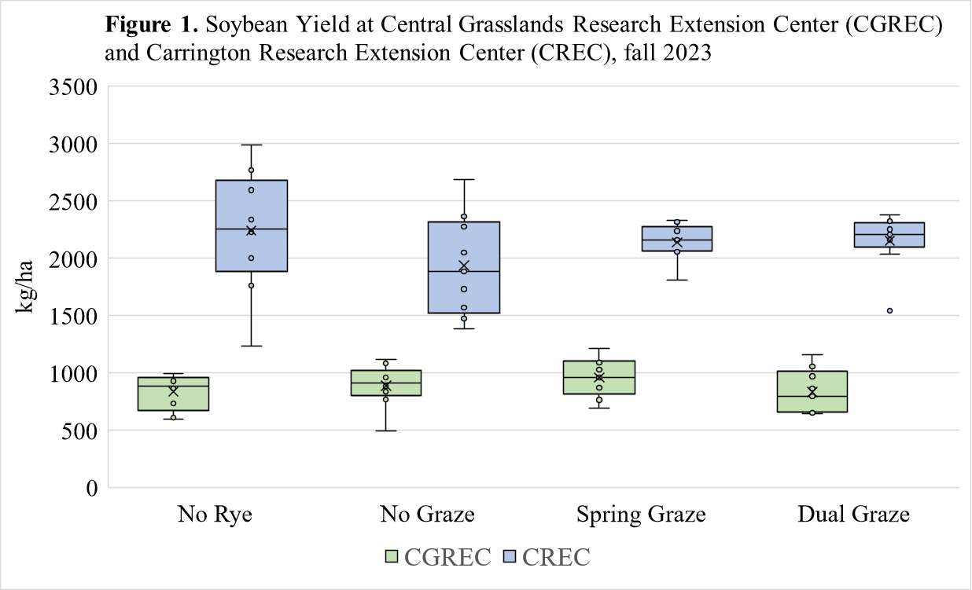
Work to be completed:
Winter rye was seeded at both locations following soybean harvest. Due to late seeding of winter rye, stands were unable to establish for the 2023 fall grazing season. Spring grazing is planned prior to corn silage seeding. Soil samples will be collected following the spring grazing period to evaluate soil health changes over the two-year period. Complete laboratory analysis of soil samples for soil microbial biomass carbon (SMBC) and arbuscular mycorrhizal fungi hyphal count (AMF).
Economic evaluation of cover crop and livestock management will be performed for 2023 and 2024. Economic evaluation will include cover crop investment, cost savings of livestock feed and housing expenses, and cash crop production.
Other Information/Potential Barriers:
Unfavorable weather during the spring of 2023 delayed spring grazing and limited the duration of the grazing period to plant soybeans within a reasonable timeframe. In addition, the late spring resulted in a delay in the entire crop season. Due to late soybean harvest, planting of the 2023-2024 winter cover crop was delayed and did not allow grazing during the fall of 2023. The late seeding may result in poor establishment of the fall-seeded winter cover crop, resulting in poor stands and reduced grazing potential in spring of 2024.
Summary:
A two-year study was established to evaluate the impacts of winter cover crop and grazing livestock management on crop systems. The objective study was to determine the impact of cover crop and livestock management strategies on soil health, cash crop production, and livestock performance. Cover crop performance was minimally impacted by livestock integration, with no significant changes in cover crop forage yield during the 2023 spring grazing season, as well as no effect on weed suppression from the winter cover crop. Livestock performance was lower than dry-lot feeding, however, grazing periods were short which lowers short-term performance. Livestock did not affect bulk density prior to soybean planting, indicating no compaction from grazing action. Soil nitrate was significantly higher at 6-12 inches within the no rye treatment at CREC While soybeans within cover crop treatments were less mature than soybeans within the no rye treatment, yield was not significantly different between any treatment.

