FY 2024 Mid-Year Report North Dakota Soybean Council
November 2023

Richard Wade Webster

Project Title: Validation of Sclerotinia sclerotiorum Apothecial Prediction Models in North Dakota and
Evaluation of Soybean Resistance to White Mold
Project dates: July 1, 2022 to June 30, 2023.
Objectives:
Objectives:
- The accuracy of predictive models (Sporecaster) for predicting white mold of soybean will be determined for North Dakota soybean production fields.
- Soybean breeding lines and additional PI lines will be screened for resistance to Sclerotinia sclerotiorum
  - A panel of soybean genotypes adapted to North Dakota will be identified with consistent resistance responses to Sclerotinia sclerotiorum for use as standard controls in future greenhouse and field experiments

Completed work:
Beginning in August of 2023, a M.S. graduate student, Sarita Poudel, joined the Soybean Pathology program and is primarily responsible for managing this project.
2023 experienced very localized development of white mold across the state with the heaviest pockets being identified in the central and southeast portion of the state under dry land conditions and areas with heavy irrigation. These pockets were primarily driven by very timely rainfall events around the flowering periods which allowed the pathogen to successfully infect, leading to severe epidemics. During these flowering periods (R1-R3), fields across Central and Eastern North Dakota were scouted for the development of apothecia, the primary source of inoculum. Similarly, between the R5 and R6 growth stages (pod fill) fields were scouted for the development of white mold and assessment of disease incidence (%). In total, 28 fields were scouted for apothecial presence or white mold development. From our scouting for apothecial presence, only irrigated locations near Oakes, ND had apothecial presence from our scouting. However, when scouting for development of white mold, high incidence of white mold was identified between Griggs and Stutsman counties ranging from 34% to 91% field incidence. For each of these locations, the GPS coordinates were recorded. Currently weather data is being pulled from each of these GPS coordinates from IBM weather services, data is being aggregated, and validation exercises are being performed on of the Sporecaster predictive models. This validation will be completed during the spring of 2024.
Additionally, work has begun on the screening of soybean germplasm lines for resistance to white mold. Due to environmental conditions, greenhouse inoculation assays can only be performed during the winter months and has been started in October of 2023. First, we have begun screening eight soybean lines from each of the maturity groups 00, 0, and 1 that come from diverse backgrounds. These lines were accessed through USDA-GRIN services. Alongside these 24 lines, four soybean check lines were included which represent susceptibility ratings of resistant, moderately resistant, moderately susceptible, and susceptible. These were included so that we can then compare against other lines and determine their resistance rating. From this initial experiment, white mold symptoms were able to develop after initial inoculation with a highly aggressive isolate, but disease development was slowed due to low levels of humidity that were present early in the infection present. To mitigate, we have installed a robust humidity chamber to improve environmental conditions for this assay. However, despite these challenges our four soybean check lines were ranked in their expected order indicating that resistance was being evaluated. Further a single line, PI548601, was identified as being highly susceptible from this experiment (Fig. 1). In order to evaluate the resistance, plants were inoculated using the cut petiole technique and a highly aggressive isolate of Sclerotinia sclerotiorum. At 7, 10, and 14 days after inoculation lesion length measurements were taken using a digital caliper. These lesion length measurements were then used to calculate an area under the disease progress curve (AUDPC) values which are represented below. With these values, a lower AUDPC represents greater resistance and a higher AUDPC represents greater susceptibility. These lines are being tested again currently to represent another experimental run. At the completion of this experiment, additional germplasm lines will be evaluated for white mold resistance. This data will assist in selecting parental lines for future breeding efforts of improved white mold resistance into agronomically favorable soybean lines with the potential for public release.

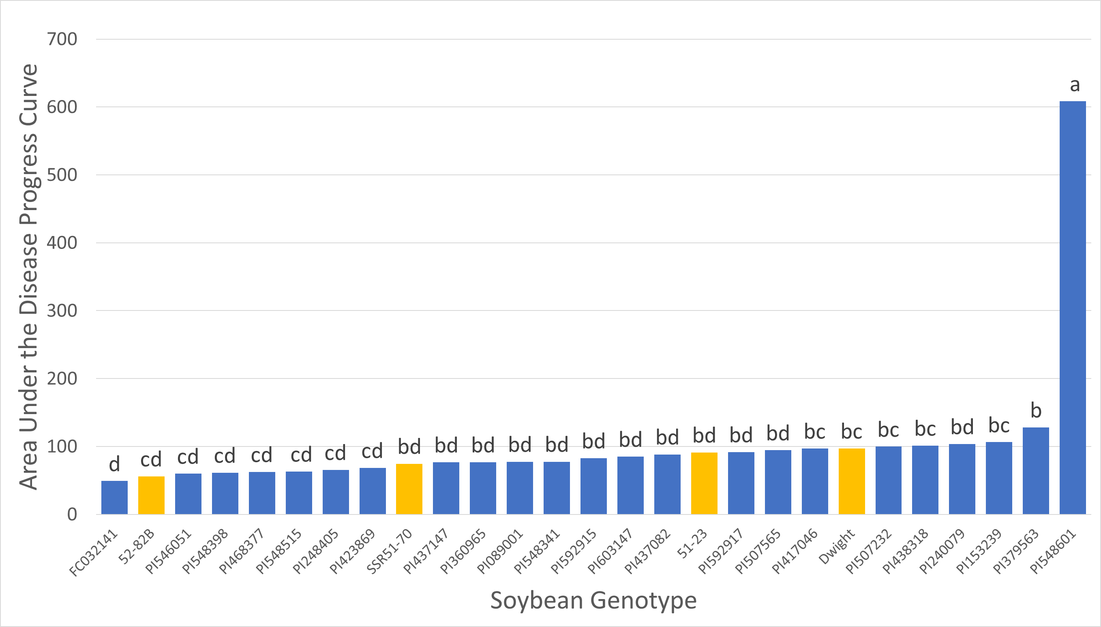
Figure 1. Evaluation of early maturity soybean germplasm lines for resistance to Sclerotinia sclerotiorum under greenhouse conditions. The gold bars represent four soybean check lines with known levels of resistance (52-82B – Resistant, SSR51-70 and 51-23 – Moderately Resistant/Susceptible, and Dwight – Susceptible).

