FY 2024 Mid-Year Report North Dakota Soybean Council
November 2023

Richard Wade Webster

Project Title: Investigating Phytophthora sojae Populations Across North Dakota Soybean Production Systems
Project dates: July 1, 2022 to June 30, 2023.
Objectives:
Objectives:
- The diversity of Phytophthora sojae pathotypes present in North Dakota soybean fields will be determined
- Phytophthora sansomeana may be identified in North Dakota soybean fields
- The current status on the effectiveness of Rps genes against P. sojae will be determined
- The soybean breeding efforts will be improved by targeting the most important pathotypes of P. sojae.
- Soybean farmers will have access to improved recommendations to manage PRSR, which includes cultivar selection

Completed work:
Despite widespread dry conditions in North Dakota in 2023, PRSR was surprisingly widespread with pockets of high stand loss due to PRSR. During the 2023 growing season, 147 soybean fields were sampled for soil through collaborations with county Extension agents, industry partners, and our own personnel (Figure 1). Our original goal was to attain 100 samples, and we well exceeded expectations. Beginning in September of 2023, an M.S. graduate student, Abdul-lateef Popoola, joined the Soybean Pathology program and is responsible for managing this project. At the end of November 2023, a total of 78 soil samples have been processed with a total of 67 isolates collected from these samples. We aim to complete all soil samples by March 2024. The currently isolated samples are also being processed for sequencing for the identification of the correct species. This will lead to the determination if P. sansomeana is present within our collection. Beginning in 2024, we will begin testing the collected isolates against our differential lines to determine races of these isolates. Once these isolates are fully tested and races determined, information can then be reported back to growers as to regional differences in the P. sojae populations present. Further, beginning in the spring of 2024, breeding lines from Dr. Carrie Miranda’s program will be screened for resistance to P. sojae races 3 and 4. This work will assist in selecting lines with complete resistance.

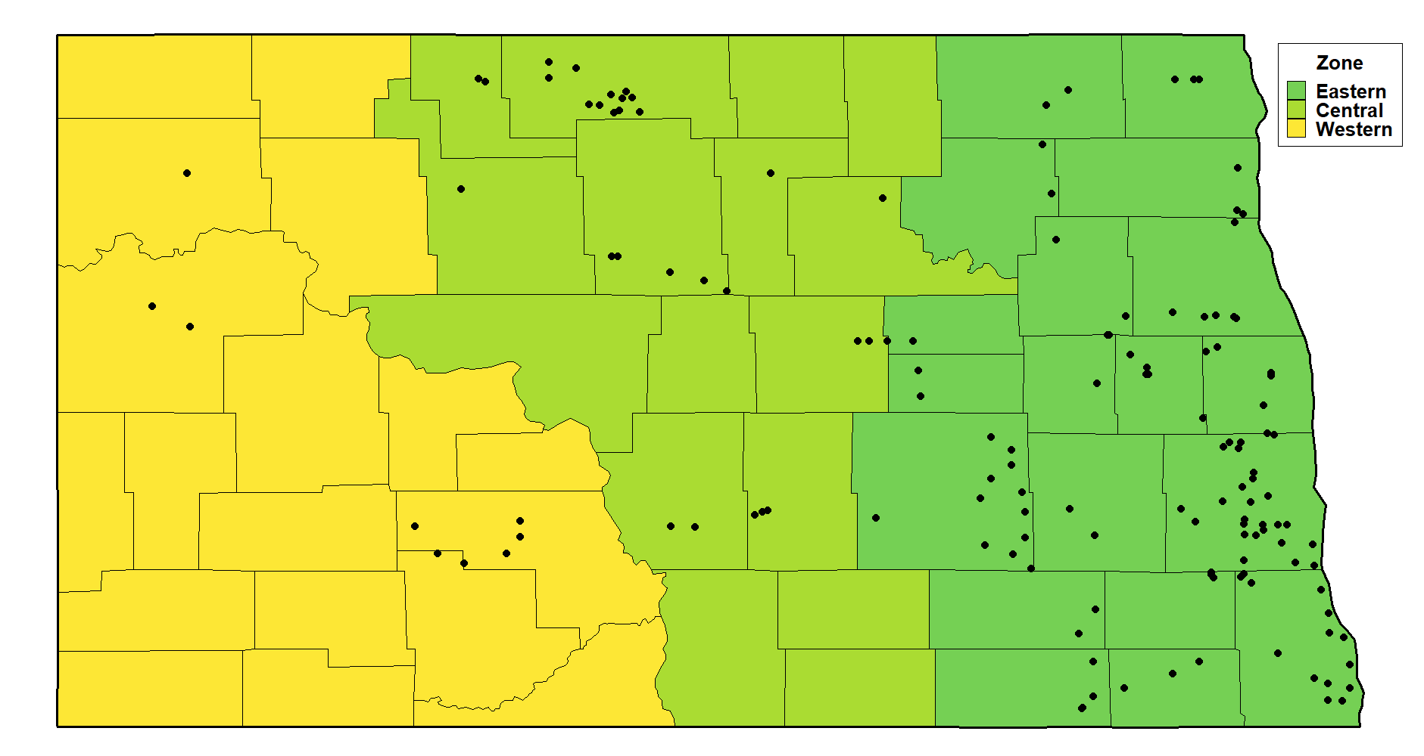
Figure 1. Map of North Dakota with locations of soil samples collected for evaluation of Phytophthora sojae populations.

