Research Project Title: North Dakota Soybeans & Pollinators: Beginning to Investigate Their Potential Interactions and Mutual Benefits
Principal Investigator: Jason Harmon, North Dakota State University
Co-Investigators: Torre Hovick and Kevin Sedivec, North Dakota State University

Research Overview
Soybeans are a crucial part of the North Dakota landscape, as are pollinating insects such as the honey bee. However, because soybeans do not require a visit by a pollinator, we often do not associate soybeans and pollinators with each other. Recent research suggests this might be a major missed opportunity for both soybeans and pollinators.

Research from other regions indicates that pollinator management can substantially increase soybean productivity. Yet, there is tremendous variation among studies in how much pollinators benefit soybeans. This means a lot more research is needed to evaluate when and how this idea could become a reliable option for ND farmers.

There may also be an opportunity for soybeans to benefit pollinators. Soybean flowers can be very attractive to pollinators, especially soybean flowers’ high quality and abundant nectar. Both the nectar and pollen soybean flowers produce can be a tremendous resource to many different pollinators, but what pollinators actually visit ND soybeans has not been researched. While soybeans only flowers for a discrete period, this flush of rewards could be incredibly valuable to pollinators that can take advantage of it. This could include honey bees that could be moved near flowering fields. Yet, little work has quantified soybean floral rewards, how they vary, and how pollinators could take advantage of them.

Objectives:
- Reveal which pollinator species are visiting and collecting pollen from ND soybean.
- Measure the floral rewards (nectar and pollen) provided by North Dakota soybean.

Completed Work: Deliverables and/or Milestones
To accomplish objective 1, we surveyed pollinators at soybean fields at Central Grassland Research Station, near Streeter North Dakota and Carrington Research Extension Station near Carrington North Dakota. Both soybean fields are part of another North Dakota Soybean Council funded project about integrating livestock and cover crops.

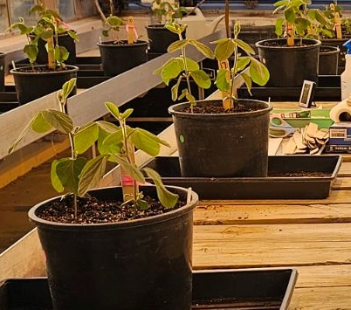
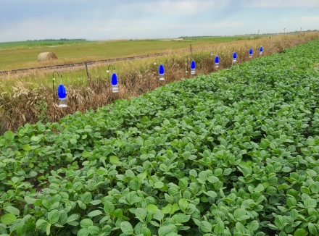
We used two, complementary survey methods to better understand the pollinators using and surrounding soybean fields around the time of flowering. We performed active surveys by freely searching for pollinators across 3-4 dates at each location. This method allows us to track the type of pollinator and their behavior when observed. We also performed passive sampling using rows of blue vein traps that were set out at the edge or in the middle of soybeans (right). Traps were left out for several hours to collect bees traveling through or near soybean. These were done on four dates across both locations.

To accomplish objective 2, we have begun a greenhouse study that will allow us to quantify pollen and nectar from greenhouse soybean plants grown in various conditions (left). We unexpectedly needed to modify a greenhouse space for our needs, but our conditions are now what we want them to be, and plants are actively growing.

Progress of Work and Results to Date
Active pollinator sampling found many more pollinators in soybean at Streeter than at Carrington (below). However, both samples were made up of honey bees and various species of bumblebees. Across all active pollinator samples, 73% of bees were actively engaged with a soybean flower in a way that looked like nectaring. This is an excellent sign that at least these groups are using, and likely benefitting from, soybean flowers.
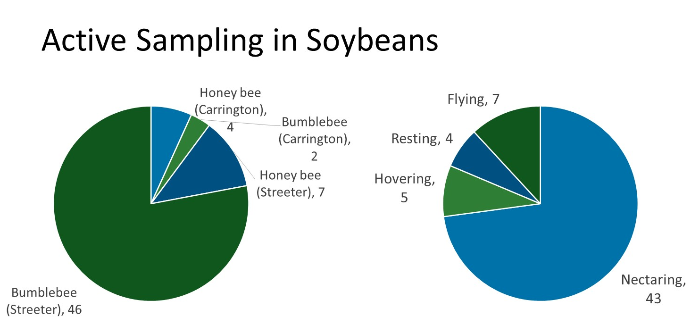
Processing of bees is ongoing for the passive sampling. Thus far, the two days at each location with the most bees have been processed and bees identified and counted. Sampling at Streeter again showed a much higher abundance of bees than Carrington, but with both locations showing a much greater diversity of bees than in the active sampling. This information will be very helpful for helping to give a broader sense of what bees could use soybean fields.

Bee | Carrington | Streeter
Longhorn bee | 181 | 547
Sweat bee | 50 | 65
Bumblebee | 1 | 106
Honey bee | 10 | 28
Cleptoparasitic bee |  | 5
Leafcutter bee | 1 | 1
Masked bee |  | 2
Miner bee |  | 2
Mason bee | 1

Work to be Completed
Objective 1. Processing and identifying of bees from passive sampling needs to be completed. When done, we will be able to better compare patterns against samples from the surrounding area as well as potential differences across time, especially as it relates to the timing of flower bloom. We are also working on using a subsample of bees to look for pollen from soybean flowers. This would be a good indicator that a pollinator visited a soybean flower as opposed to simply traveling near or through a soybean field.

Objective 2. Our greenhouse study is underway with plants actively growing. At flowering, we will begin sampling plants for both pollen and nectar to improve our methodologies with both techniques. While we know greenhouse grown soybeans can vary greatly from field plants, this will give us a starting point for a manipulative experiment that we will perform this spring that will vary greenhouse plants by environmental condition. It will also improve our ability to perform similar measurements in the field if we are funded to continue our work next summer.

Other relevant information: potential barriers to achieving objectives, risk mitigation strategies, or breakthroughs
Processing bees for pollen and then identifying where that pollen comes from can be difficult and time consuming, but we have recent experience in this area and confident we have the tools developed to accomplish this part of the objective, even if it is done on a subset of all collected bees.

Collecting floral rewards, particularly nectar, can be difficult for many plant species. However, we have experience modifying methods and developing alternatives as needed. We are also planning on improving our techniques for this with our first batch of greenhouse grown plants.

Summary
Our pollinator sampling this summer was quite successful and is giving us insights on the bees that have the potential to interact with soybean flowers and those that have actually visited flowers. These results have also been very helpful in developing more efficient plans for next summer. Our greenhouse objective has taken some effort to develop the appropriate conditions and growing logistics, but those obstacles have been overcome and plants are actively growing to let us accomplish our second objective before next summer.

