Goal: The overall goal of this project is to advance genomics-assisted breeding for the development of future superior soybean varieties improved for both yield and composition. We will accomplish this using a multipronged approach including developing better breeding methods and furthering routine implementation of genomic prediction in actual public soybean breeding programs.
Our overall goal can be broken down into three interrelated objectives:
1. Continue to develop and enhance genomics-assisted breeding resources and tools to facilitate routine application in public breeding programs.
The SOYGEN3 project officially kicked off this past reporting period. We held several meetings to refine goals and share information on use of markers and genomic selection in our own variety development programs. There are four specific tasks we are undertaking to advance this goal:
- Collection of low-pass resequencing data on all advanced breeding lines entering the Northern Uniform Soybean Tests (NUST) and SCN NUST. This past year, we collected tissue on 611 new advanced breeding lines and submitted them for low-pass sequencing. This returned around 3 million SNP markers for each breeding line. We received the data last fall and have been working on processing these data and importing them into our new database, Soybeanbase. Seeds have been received for the 2024 cohort of NUST and NUST SCN lines. We are packaging those for planting and summer genotyping.
- We have continued to deposit data and work on the Soybeanbase database with the Breeding Insight Onramp team. https://soybeanbase.breedinginsight.net/. This database now holds all the 6K genotype data collected on the breeding lines entered into our regional trial networks. We are preparing a publication reporting the analyses of these genotype data. This manuscript should be submitted in the coming months, and will make the availability of these data widely known to the larger community, and thus will become an important resource for soybean breeders and geneticists. The UMN Breeding group has also deposited internal genotyping data into this database. It is our hope that once expertise within one group can be established, we can share that expertise the other breeding groups.
- A workflow and software application has been developed to streamline the process of and analysis to enable genomics-assisted breeding. Once standardized data files are entered, a practitioner can walk themselves through the GS process using a graphical user interface. This should democratize the use of genomic prediction for soybean breeding, and allow breeders to do quick analyses to make selections on quick deadlines. See this link for a demo of the application, and the screenshot of the workflow below.
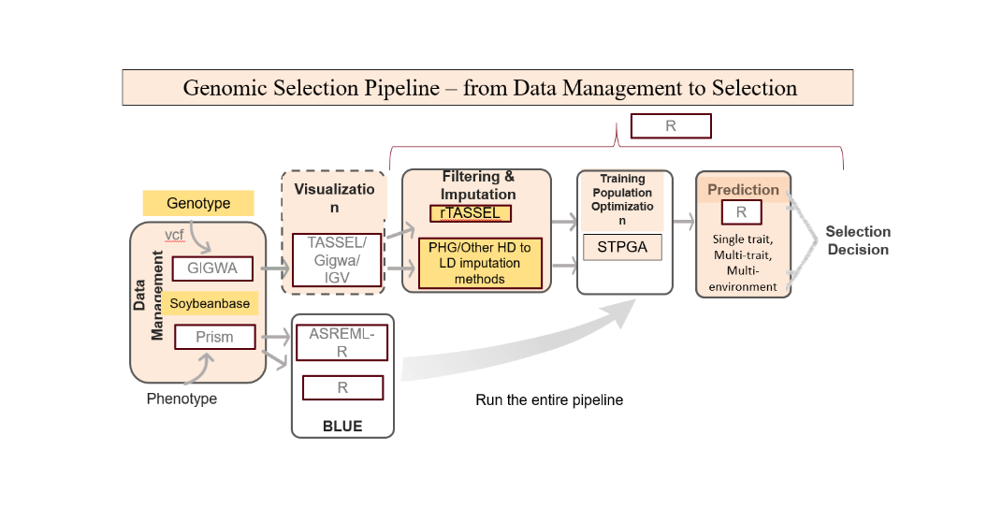
- In the past, we conducted a wide-scale test to compare genomic selection to phenotypic selection. This experiment is being repeated in 2023 for another season of data collection. For the new SOYGEN3 project, each breeder will genotype ~1000 breeding lines in their program and attempt to use genomic selection that best fits their current program and needs. This will start in the summer of 2023.

2. Develop and test methods for predicting cultivar performance in future target environments through genomics-assisted breeding models, phenomics, and environment characterization.

- For this objective, we are conducting a multi-environment, multi-institutional coordinated performance trial of 1200 diverse breeding lines. Each breeding line will be phenotyped for several agronomic and phenological traits, and each will be genotyped using low pass re-sequencing technologies. Detailed environmental for each growing location in each year will be collected and analyzed. The ultimate goal is to better predict the interactions between the environment and genotype. If we are successful, we leverage genomic data, phenotype data, and environmental data to predict how new breeding lines may perform in future environments that a producer is most likely to encounter.
This project is just getting off the ground. The first step is to identify the breeding lines making up the panel, and increase their seeds all common growing environments to remove any effects related to seed source. This past funding period, we identified 300 breeding lines per relative maturity (RM) grouping. There are four RM groupings, for a total of 1200 breeding lines. Breeders were given listings of lines, and are currently exchanging seeds in order to plant small seed increases that will produce at least three pounds of seed. These seeds will be used for performance trials in 2024. We have designated seven hubs for increasing seed. ND and MN will increase seeds of the 0.5 – 1.5 RM set, IA and NE will increase seeds of the 1.5 – 2.5 RM set, IN and NE will increase seeds of the 2.5 – 3.5 set, and KS and MO will increase seeds of the 3.5 – 4.5 set. Each set is assigned two seed increase locations to protect against natural disasters such as drought and hail. Plans for collecting tissue and phenotyping of these seed increase plots are currently being discussed.

- Discover structural variants and test whether modelling structural variants improves genomic predictions for yield and seed composition.

- For this objective, we will apply long-read sequencing technologies to discover structural variants in soybean. We will perform this on the Soybean Nested Association Mapping population, which is a widely used population on which quality phenotype and molecular marker data is available. This will allow us to determine if knowledge of genomic structural variation has any value for predicting phenotype from genomic data.
During this reporting period, co-PI Hudson obtained seed of the original 41 SoyNAM founders (original sources used to make the crosses). These seeds were planted in the greenhouse and tissue was collected for DNA isolation. DNA isolation is in progress, and will be sent out for sequencing during the next reporting period.

The following will be delivered upon completion of this three-year project:
1. Publicly available resources and tools for soybean breeders to implement cost-effective genomic prediction in their programs.

2. Publicly available knowledge on genetic control of genotype-by-environment interaction in soybean, and improved models for prediction of breeding line performance in new environments. Knowledge will be made available through open-access publications, presentations at scientific meetings, and presentations to the seed industry.

3. Identification of important structural variants that control seed yield and composition, and publication of knowledge on any benefit into explicitly modeling structural variants for predicting breeding line performance.

- Enhanced germplasm and superior varieties developed through adoptions of genomics-assisted breeding techniques better adapted to future environmental conditions.

1. Approximately 425 – 450 new advanced breeding lines entered into the uniform regional trials genotyped each year using low-pass sequencing technology.

2. The “SOYGEN Genomic Selection” application and/or Breedbase installation at SoyBase.org is fully operational and used by majority of participating soybean breeding programs for managing genomic selection programs.

3. Low density genotyping-to-high density genotyping imputation leveraging pedigrees integrated into tools described in KPI #2.

4. By end of third year, majority of participating breeding programs are using genomic selection and developed GEI models routinely.

5. GEI panels are selected, genotyped, and phenotyped at characterized environments, and full dataset is provided to SOYGEN team members. These data will subsequently be made publicly available at SoyBase.org.

