Project Title- Integrated agricultural systems to promote soil health and environmental resilience
This project is an extension of a long-term study evaluating the impacts of field management combining poultry manure, cover crops, and reduced tillage. In 2021, the Land mAnagement for improved Yield, Environmental Resilience, and Sustainability (LAiYERS) research site was established and the treatments were initiated with our first soybean crop planted after the subsurface drainage tiles and sampling wells were installed (Fig 1). The Iowa Egg Council funded initial plot establishment, site development, and continued research. Funding for the soybean crop analysis, water quality, and soil characteristics was provided by Iowa Soybean Association. The system considers manure application timing, cover crops, strip till, and nutrient application timing. This unique study will provide important information to farmers on how to best manage these systems for a range of environmental benefits, including soil health and resiliency to climate change. Ongoing evaluation of water quality and soil health is essential to measure and identify impacts of combined management practices.
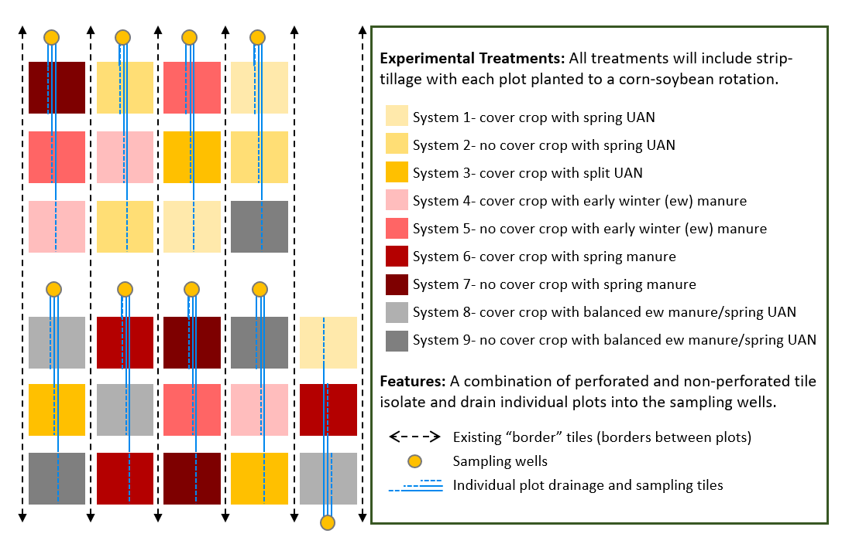
Figure 1. Schematic illustration of the plot layout and features. The experimental treatments (System 1-9) were randomly assigned in a block design determined by site soil characteristics. Treatments include manure or chemical fertilizer (UAN) application before corn, with early winter or spring poultry manure at 150 lbs N/acre; spring UAN at 150 lbs N/acre; balance poultry manure with UAN with an early winter poultry manure at 150 lbs N/acre followed by UAN at 150 lbs N/acre; and split UAN with 100 lbs N/acre spring applied and 50 lbs N/acre as sidedress.
Each of the nine system treatments are replicated in triplicate. The spring UAN treatments, with and without cover crops, serve as the experimental control. Supplemental nutrients, such as phosphorus, will be applied as field conditions indicate. An additional UAN treatment includes a split UAN application with spring side dress to address concerns with yield loss due to potential low nitrogen availability following cover crops. The manure application treatments allow for a side by side comparison of early winter and spring manure application with and without cover crops. We also include a balanced manure treatment with manure applied every 5 years (early winter application after soybeans in years 1 and 3). The plot and sampling well installation was completed in June 2021. Plumbing in the sampling wells and flow monitoring instrumentation has continued through 2022 as we prepare for electrical installation to the sampling wells. We anticipate electrical installation to be completed in November of 2022.
Soil and subsurface drainage water sample results were analyzed in the fall of 2022 and are highlighted here. The first year of subsurface drainage water results show differences in NOx-N concentrations with treatment (figure 2).

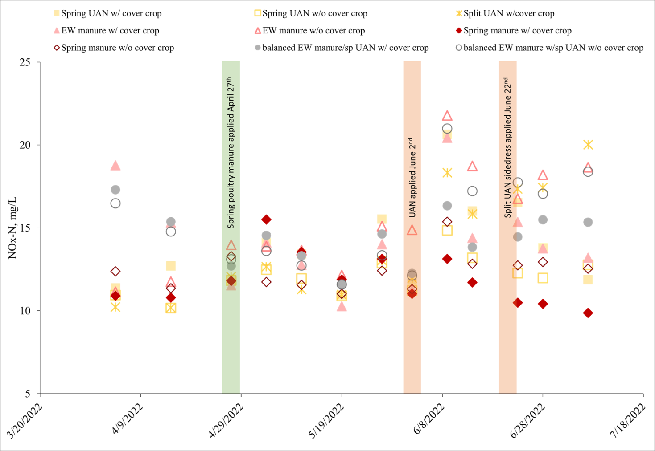
Figure 2. Average subsurface drainage water nitrate (NOx-N) results throughout the season. Significant differences were not identified due to high variability in concentrations with all treatments throughout the drainage season.
Manure or UAN fertilizer application timing impacted concentration results, with expected increases in concentrations after spring manure and UAN applications. In general, plots that were treated with manure in early winter 2021 (EW manure and balanced EW manure) had much higher early spring concentrations compared to the other treatments.
Fall soil analysis showed accumulation of phosphorus in the surface soil (0-6”) at plots that were treated with manure in early winter 2021 or spring 2022. All plots have M3-P levels indicating high or very high phosphorus. Total available nitrogen was relatively low in the fall for all treatments.
Table 1. Select fall 2022 soil analysis results. Phosphorus (M3-P) and potassium (K) results reflect accumulation with manure treatments. All 0-6” soil phosphorus results indicate high to very high phosphorus levels. P and K were applied to the UAN plots in December 2021 at a 2-year removal rate of 100 lbs/acre P₂O₅ and K₂O.

Progress Toward Project Metrics
KPI #1: Data on yield, soil and water quality. Measured annually by collection of environmental datasets.
Fall soil samples were collected on 11/3/22-11/4/22 and delivered to AgSource Laboratory in Ellsworth, IA for analysis. Select soil analysis results are presented in this report. Subsurface tile drainage water samples will be collected throughout the 2023 drainage season, with the first samples estimated to be collected in mid-April. Soybeans will be planted by May 15th, and soybean plant analysis will be conducted periodically throughout the growing season.
KPI #2: Improved understanding of manure integrated cropping systems and their impact on soybean yield and soil and water quality.
This metric will be achieved through continued progress on KPI #1. We are beginning the third year of research and data collection at the LAiYERS plots. The preliminary results indicate differences in water quality, specifically nitrate concentrations, in response to treatment. The lowest nitrate concentrations were measured Although the plots were planted to soybeans in 2021, these plots had yet to receive the first fertilizer-cover crop combination treatments. The 2023 soybean crops will be the first year to reflect treatment impacts.

