Determination of optimum irrigation amount and timing for enhanced soybean yield, quality, water productivity, and soil health under semi-arid western ND
(Mid-Year Report)
Gautam Pradhan, PI
Tyler Tjelde, Co-PI
James Staricka, Co-PI
NDSU Williston Research Extension Center
Objectives
- The main objective of this project is to determine the optimum amount and timing of irrigation for enhanced soybean yield, quality, and water productivity.
- The secondary objectives are to assess the effect of irrigation treatments on the
  - soil health manifested by changes in soil physical and chemical properties, and
  - manifestation of soybean diseases including but not limited to white mold

Completed works
- A glyphosate-tolerant soybean variety ND 17009GT was seeded at the Williston Research Extension Center, Nesson Valley Irrigation Site, Ray, ND (Longitude: -103.1069, Latitude: 48.1630) on May 27, 2022, under randomized complete block design with four replications. The seeding rate was 195,000 PLS/ac with Row to Row distance of 30 in and a gross plot size of 59’ X 50’.
- There were 12 irrigation treatments:
I = Full irrigation; Wv = Deficit irrigation during vegetative [(VE – V(n)] stage; Wf = Deficit irrigation during flowering [R1-R2] stage; Wp= Deficit irrigation during pod development [R3-R4] stage; Ws = Deficit irrigation during seed filling [R5-R6] stage; Wm = Deficit irrigation during maturity [R7-R8] stage; Wvf = Deficit Irrigation during vegetative + flowering stages; Wvp = Deficit irrigation during vegetative + pod development stages; Wvs = Deficit irrigation during vegetative + seed filling stages; Wvm = Deficit irrigation during vegetative + maturity stages; Wsm = Deficit irrigation during seed filling + maturity stages; and R = rainfed.
- Soil water contents at six different depths (from 6” to 36”) were recorded 15 times from June 22 to September 6, 2022.
- Unmanned aircraft systems equipped with multispectral, thermal, or RGB cameras were flown over the experimental field at different dates to assess canopy temperature (CT), normalized difference vegetation index (NDVI), and normalized difference Red Edge (NDRE).
- At maturity, plant height was measured, biomass was collected, and the crop was harvested using a plot combine.

Preliminary results
- The preliminary results from 2022 showed a significant difference among irrigation treatments for the NDVI of soybean.
- The NDVI imageries from August 19, 2022, showed a slight decrease in greenness in rainfed (R) plots compared to others (Figure 1A).
- The NDVI image collected on September 1, 2022, showed a marked decline in greenness in rainfed (R) plots and plots that had deficit irrigation during pod filling (Wp) and vegetative + pod filling (Wvp) stages (Figure 1B).
- The NDVI image collected on September 15, 2022, showed a marked decline in greenness in all the plots manifesting senescence of the soybean under all the treatments (Figure 1C). However, it is clear from the figure that the senescence occurred at a higher pace in rainfed (R) plots and plots that had deficit irrigation during pod filling (Wp) and vegetative + pod filling (Wvp) stages compared to others.
- This year, during the soybean vegetative stage, there were frequent and heavy rains. Therefore, although irrigation was not applied, soybean did not experience any drought at the vegetative stage, which is apparent from Fig.1A and B. For example, there was no difference for NDVI between Wf and Wvf, Wp and Wvp, Ws and Wvs, Wm and Wvm, and I and Wv.

Figure 1. NDVI of soybean under different irrigation treatments and dates.
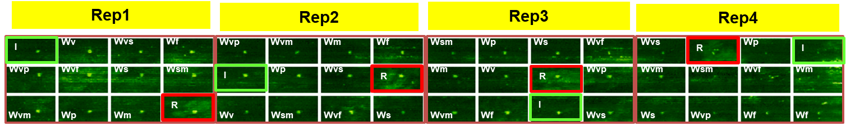
- August 19, 2022

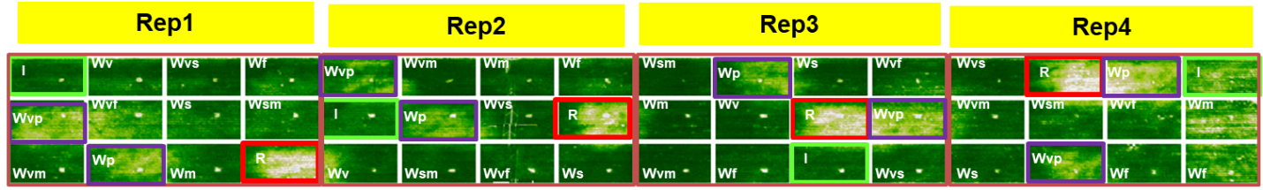
- September 1, 2022

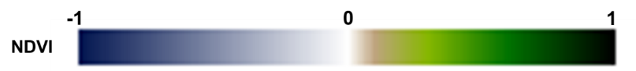
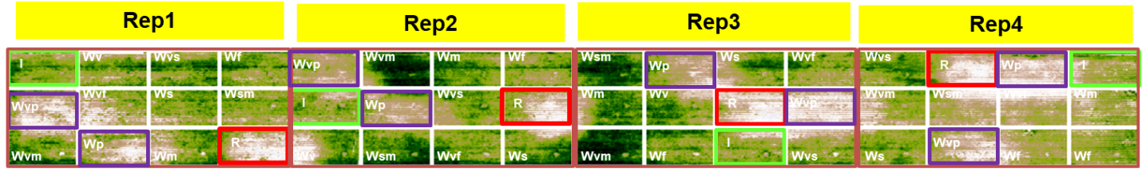
- September 15, 2022

- There was a significant effect of irrigation treatments on soybean grain yield. As clear from Figures 1B and C, Rep 4 showed a marked decline in greenness in all plots compared to plots under Rep 1 to 3 because of gopher damage. Therefore, we excluded yield data from Rep 4 in the statistical analysis.
- As mentioned for NDVI, because of frequent and heavy rains during the vegetative stage, there was no difference between Wm and Wvm, Wvs and Ws, I and Wv, Wf and Wvf, and Wp and Wvp for grain yield as well (Figure 2).
- The treatment Wsm produced the highest grain yield, which was statistically on par with other treatments: Wvm, Wm, Wvs, Ws, I, Wv, and Wf.
- A marked decline in yield occurred for treatments Wvf, Wp, Wvp, and R compared to Wsm and Wvm.
- The preliminary data showed a possibility of saving an amount of irrigation water without any decrease in soybean grain yield, provided that the escaping of irrigation does not occur at the flowering and pod development stages.

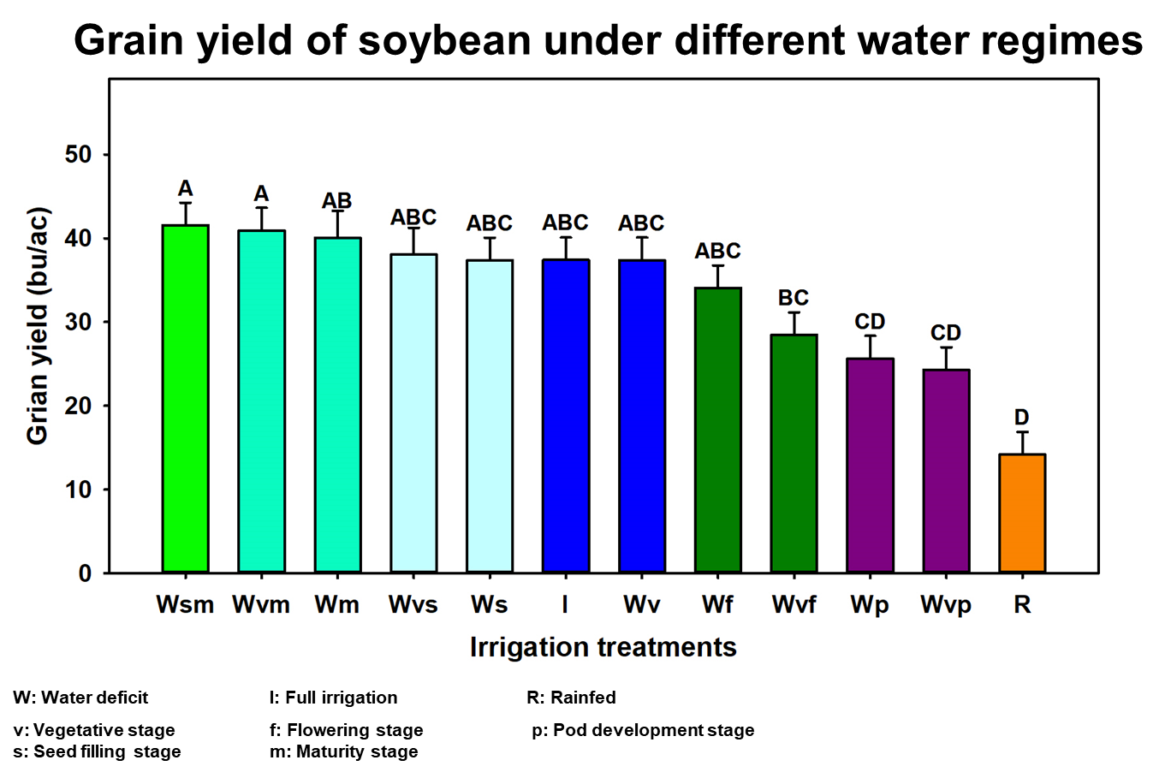
Figure 2. Soybean grain yield under different irrigation treatments.

Works to be completed
(i) Biomass processing. (ii) Analyses of data on yield components from the processed biomass. (iii) Processing and analyses of data on growth and physiology (NDRE and Canopy Temperature) acquired by the Unmanned Aircraft System. (iv) Analyses of data on soil moisture collected by neutron probes, and data on soil physical and chemical properties from laboratory analyses. (v) Reporting of final outcomes to clientele and North Dakota Soybean Council.

