South Dakota Soybean Research and Promotion Council October 28, 2022 (Q 1)
Prepared by David Clay
Achieving 100 Bu/A soybean yields: on-farm research and sharing high yield protocols with South Dakota soybean producers
Principal investigators: David Clay, 688-5081, david.clay@sdstate.edu, Agronomy, Horticulture, and Plant Science Department, SDSU, Brookings SD; Sharon Clay, Sharon.clay@sdstate.edu, Connie Strunk, connie.strunk@sdstate.edu; and Anthony Bly, Anthony.bly@sdstate.edu;
Advisory board: David Iverson, David Wright, Craig Converse, Gordon Andersen, and Kyle Gustafson (Winfield Solutions)
On-farm studies provide information that producers use to reduce the economic risks associated with new products, test the efficiency of components within their current operation, and test innovative new ideas and concepts. In the project, a producer chooses his/her treatments based on their interest or desire prior to implementation. SDSU agronomists assist in experimental design, treatment application, scouting, and analysis. At the completion of the project, reports are distributed to the farmer collaborator, and they are posted SD Soybean Research and Promotion on-farm web site. Farmers use results from the study to identify treatments that might be success on their farm and reduce the economic risks associated with new products. To date, over 450 experiments have been conducted by SD farmers. SDSU undergraduate students are using the on-farm studies for their capstone class and planning for SOY100 2022 has started. We just received word that the American Ethanol Coalition and SDSU were funded in a UDSA-RCPP project focused on soil health. This project is centered around Madison, and it will provide funding for the adoption and quantification of BMP on soil health. We are in the process of identifying collaborators for this this on-farm study. This new project will help expand our on-farm research on soybeans and soil health.

- Continue the on-farm research program in 2021;
- Continue research designed to determine the importance of soil health in optimizing soybean
- Deliver information to producers through Soy100, AgOutlook, SD on-farm web-site, news releases, radio interviews, and SDSU websites.
- Use data collected in the on-farm SDSU classes (PS475 and PS428)

Objective 1: Continue the on-farm research program in 2021;
Table 1. 2022 experiments in soybean fields testing new products. Red color highlighted are new farmers enrolled in 2022.
Farmer | County | Treatment | # of Trials | UAV
Minor, Lance | Aurora | Vitazyme in-furrow | 2 | √
Minor, Lance | Aurora | GoldStart in-furrow | 2 | √
Minor, Lance | Aurora | Seeding rate reduced by 30k | 2 | √
Minor, Lance | Aurora | Seeding rate increased by 30k | 2 | √
Hamilton, Jeff | Beatle | compost | 2
Ostrem, Tim | Beresford | Vitazyme in-furrow | 2 | √
Hanten, Todd | Codington | Vitazyme in-furrow | 2 | √
Holzwarth, Luke | Codington | Vitazyme in-furrow | 2 | √
Strom, Nick | Groton | foliar fungicide | 2 | √
Martinmaas, Tyson | Highmore | foliar fungicides | 2 | √
Jorgensen, Bryan | Kimbell | Biological seed treatment | 2 | √
Jorgensen, Bryan | Kimbell | SG Assist - Starter | 2 | √
Jorgensen, Bryan | Kimbell | foliar micronutrient | 2 | √
Strom, Corey | Kimbell | Sound Ag foliar | 2 | √
Carlson, Scott | Kingsburry | Starter | 2 | √
Converse, Craig | Kingsburry | Vitazyme in-furrow | 3 | √
Alverson, Keith | Lake | Populations | 3 | √
Alverson, Keith | Lake | Varieties | 3 | √
Renaas, Doyle | Lake | Vitazyme seed treatment | 2
Loewe, Matt | Lincoln | low seeding rate | 3 | √
Loewe, Matt | Lincoln | high seeding rate | 3 | √
Dave Claussen | Miner | salinity | 2 | √
Scott, Kevin | Minnihaha | Vitazyme in-furrow | 2 | √
Harnisch, Matt | Mitchel | winter rye cover crop | 2 | √
Paul Westhoff | Salem | Different landscape | 2 | √
Fischbach, Chris | Warner | Sound Ag foliar | 2
Fischbach, Chris | Warner | Vitazyme foliar | 2
Fechner, Darren | Yankton | Vitazyme in-furrow | 4 | √
Van Osdel, Brandon | Yankton | foliar fungicide | 2 | √
Frank Nedved | Yankton | Variety | 3 | √
Chad Malone | Kingsbury | Soil Health | 2 | Sampled
Ed Wilkinson | Kingsbury | Soil Health | 1 | Sampled
Chad Malone | Kingsbury | Soil Health | 1 | Sampled
Greg Albrecht | Kingsbury | Soil Health | 1 | Sampled
Paul Casper | Kingsbury | Soil Health | 1 | Sampled
Paul Casper | Kingsbury | Soil Health | 1 | Sampled
Scott Jensen | Kingsbury | Soil Health | 1 | Sampled
Jon Nelson | Kingsbury | Soil Health | 1 | Sampled
Lynn Jensen | Kingsbury | Soil Health | 1 | Sampled
Brett Anderson | Kingsbury | Soil Health | 1 | Sampled
 |  |  | 79
When compared to 2021-2022, the number of projects has increased from 63 to 71. Ten of these new on-farm projects are associated with soil health. The soil heath projects will be ongoing efforts over the next several years.
Table. Total list of the trail in 2022. Yellow color highlighted are new farmers enrolled in 2022.
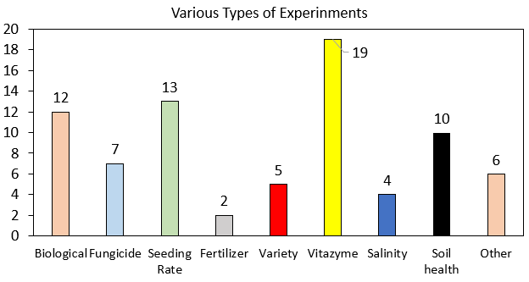
Total Farmers enrolled: 31
New farmers enrolled: 15
Total counties involved: 17

Figure 1. Various types of experinment conducted and their total numbers.
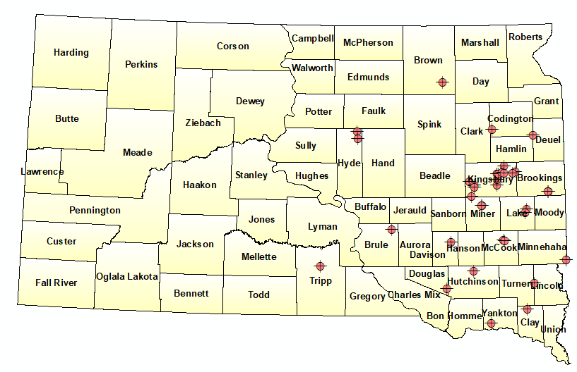
Figure 2. Distribution of different experinment at different counties of SD state.
Objective 2: Continue research designed to determine the importance of soil health in optimizing soybean yields (partially funded by NRCS and NREC).
Ten new on-farm studies on soil health were initiated. These projects are designed to answer several important questions that include will the adoption of cover crops when combined with reductions in the tillage intensity and adoption of the 4R technologies simultaneous improve soil health, productivity, and profitability. Treatments are being applied in large strips across fields.
Objective 2: Develop PF algorithms that can be used by SD farmers to predict yields.
We are developing an in-season algorithm that can be used to predict soybean yields prior to harvest. In this work we are testing different machine learning algorithms. A summary of this work is below.
In modern precision agriculture, preharvest yield prediction plays a critical role in various decision-making process such grain policy making, crop marketing, price forecasting, insurance, and harvest plan. This paper presents deep neural network (DNN) as deep learning model and various machine learning based models such as random forest (RF), support vector machine (SVM), LASSO and ADABOOST in combination with high resolution satellite imagery to predict soybean yield in field scale level. Six high resolution satellite images (3.12 x 3.12m) at various growth stage of the soybean plants were used in 2019 and 2021 at three different locations of South Dakota. Ten different vegetative index (VI) were calculated from each derived images and yield data using yield monitoring system were used to predict soybean yield. Coefficient of determination (R2) and root mean squared error (RMSE) were utilized to evaluate the performance of models. Out of all tested models, DNN found to outperform to predict soybean yield across all locations and years. The reason behind its best accuracy was its multiple stacked nonlinear layers which resulted DNN as one of the most powerful nonlinear models. In our analysis we had 5 hidden layers and 50 neurons in each layer. Additionally, it applied cutting-edge deep learning methods like batch normalization and drop out, which improved overall prediction accuracy in comparison to other models. Moreover, accuracy of such model can be improved more by incorporating various environmental variables such as temperature, rainfall, soil type, elevation, and crop management in the models.
Objective 2: importance of cover crops
We conducted a detailed review article on the potential for cover crops to improve soil health. The abstract is below.
By influencing soil organic carbon (SOC), cover crops play a key role in shaping soil health and hence, the long-term sustainability of our crop production systems. However, the magnitude by which cover crops impacts SOC depends on multiple factors, including soil, climate, management, cover crop growth, and years under management. To elucidate how these multiple factors influence the relative impact of cover crops on SOC, we conducted a global meta-analysis by searching published articles, which assessed changes in SOC with and without cover crops within corn (Zea mays L.) production systems. Information on climatic conditions, soil characteristics, management, and cover crop performance were extracted, resulting in 198 paired comparisons from 61 peer-reviewed studies. Overall, cover crops grown in corn rotations increased SOC from 4.9 to 9.6%(95% CI). The SOC increase was attributed to CO₂ fixation by the cover crop being greater than the amount of SOC lost through respiration. Furthermore, % SOC improvements under cover crops are more evident in soils with continuous corn systems, as well as in tropical and temperate climatic zones. Our results suggest that current cover crop-based corn production systems are sequestering 5.5 million Mg of SOC-C year⁻¹ in the United States and has the potential to sequester 175 million Mg SOC year⁻¹ globally. These findings can be used to improve carbon footprint calculations and develop science-based policy recommendations. Taken altogether, cover crops are a gold-standard practice to sequester atmospheric C and hence, make corn production systems more resilient to changing climates.

Objective 3: Distribute information to farmers
Planning activities for Soy100 2023 meeting.
Planning for Soy 100 is underway. The planning committee consists of Adam Kask, Maria Kessler, Maggie VanderLaan, David Iverson, Kyle Gustafson, Anthony Bly, Connie Strunk, David Clay, and Shaina Westhoff. The date for Soy 100 is set for March 16th, 2023, and will be held at McCrory Gardens in Brookings, SD. Sodexo will cater the event. Based on last year’s interest, anticipated participation is between 150 and 200 attendees. Mr. Tregg Cronin will be the keynote speaker on Marketing and Economics. Additional morning talks will encompass soybean production and anticipated climate trends. The afternoon will provide three breakout sessions for attendees that include Marketing and Economics, Soybean Diseases, and Soybean Nutrient Management.
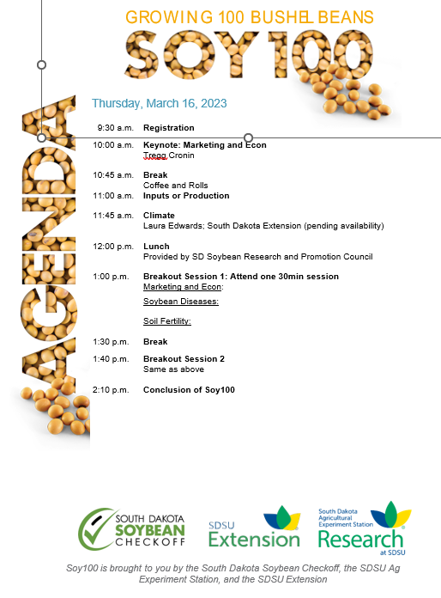

Presentations
- Clay, D.E. 2022, Carbon neutrality, Kick off for endowed chair lectures at SDSU, September30, 2022. Brookings, SD attendance 30
- Clay, D.E. 2022. Kick off meeting for RCPP, Madison SD, September 13, 2022. Attendance 120.
- Clay, D.E. 2022. Everything counts, farm-to-biofuel carbon market opportunities. American coalition of Ethanol. Omaha, NE, August 23, 2022.
- Brugler, S., and Clay. D.E. 2022. The influence of nitrogen stabilizers in no-till corn production on nitrogen losses to the atmosphere. NUE meeting, Lincoln NE, August 1-3, 2022
- Bhattarai, D., Clay, S.A., Clark, J.D., Clay D.E. 2022. Prediction of no-till corn N requirement that considers soil health. NUE meeting, Lincoln NE, August 1-3, 2022

Objective 4. Students enrolled in advanced classes are using on-farm studies in undergraduate research projects.
Addition information will be made available as these studies are completed.

