The UofMN/MSR&PC Drainage and Tillage Research Site:
Enhancing Soybean Production with Residue
Management and Cover Crops

Semi-Annual Progress Report

By:
Seth Naeve, PhD
Carlos Sanchez

Project Summary
Although soybean is regarded as a crop with a high level of competition and resilience, early-season growth and development are essential to optimizing yields. Although planting in the early spring is crucial, crop potential is ultimately determined by spring vigor and growth rates. In other words, early season vigor and emergence dates are more important for determining soybean yields than planting dates. Research on drainage, tillage, and residue/cover crops is now more important than ever because of the considerable changes in rainfall patterns that have increased the frequency of extremely heavy rainfall events.

The project consists of a wide range of contemporary crop management scenarios to examine many aspects of temperature, water, and nutrient availability and their effects on early planted soybean. Also, the complex design of this project allows to investigate the effects of crop residues and examine the three-way interactions between residue quantity and quality, tillage, and drainage.

This is a first-of-a-kind experiment to evaluate effects of drainage, tillage, and residue on soil temperatures, moisture, and nutrient availability at the seed and in the rhizosphere of early-season and season-long soybean growth in Minnesota.

Project Methodology

The study is located in a long-term research site near Wells in south-central Minnesota. The site is divided into eight blocks where four blocks were randomly assigned to be drained and four were randomly assigned to be undrained. Each of these blocks is subdivided to accommodate corn and soybean crops that rotate every year. The three levels of tillage treatments are 1) conventional, 2) strip-till, and 3) no-till. The three levels of residue management that started last fall 2021 are: 1) corn residue removed, 2) cover crop planted in the fall and terminated in spring, and 3) traditional (residue left on the field). This treatment structure allows to examine the effects of seed treatments and seeding rate (125k and 140k) across these multiple factors.

Project Deliverables
The key component of this project is examining the environmental and physiological effects of these systems and the impact of them on yield and quality of soybean.

Soil moisture measurements
Because soil can vary greatly from place to place, extensive measurements and expensive study are often necessary. Four soil-plat-weather ground-based monitoring sensors (TEROS 12, Meter Group, Inc., Pullman, WA) are installed at four different depths (2”, 6”, 12” and 24”) considering the heterogeneity of the soil, spanning the entire root zone, in 32 different plots across the eight blocks. In order to map plant water stress, data from these sensors is sent back to the decision support system ZENTRA cloud (Meter Group, Inc., Pullman, WA). The measurements are taken on intervals of an hour, from early-season (May) through harvesting (~October).
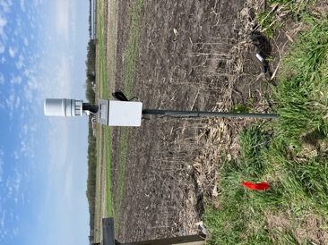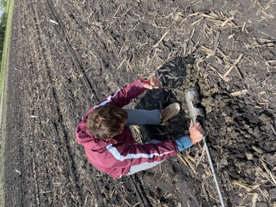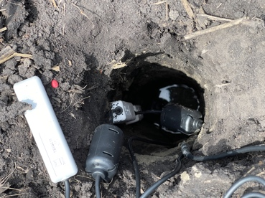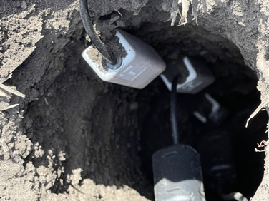
Installation of the weather station and soil monitoring sensors.

Soil compaction
When soil particles are compressed, the amount of pore space between them is decreased, resulting in soil compaction. Soils that have been heavily compacted have fewer big holes, less total pore volume, and therefore a higher density. Water infiltration and drainage are both less rapid in compacted soil. This occurs because larger pores have a greater ability than smaller pores to transport water through the soil at a downward angle.

For the measurements of soil compaction, the use of a digital penetrometer was required. The measurements were performed at two different timings: right after planting, and at the soybean stage V2.
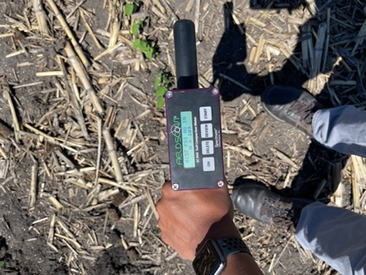
Use of the digital penetrometer to measure difference
in compaction by the tractor between rows.

Plant Root Simulator (PRS®) probes
In agronomic, forestry, and ecological research, PRS® probes are an indispensable instrument because they provide a practical and affordable way to assess both geographical and temporal variations in nutrient supply rates for all soil ions at once.

The rate of nutrient supply for nitrate (NO₃-N), ammonium (NH₄-N), and phosphorus (P) accessible to plants was measured before planting and during the growing season using Plant Root Simulator (PRS)TM probes with ion-exchange membranes (Western Ag Innovations, Saskatoon, SK, Canada). In four plots at each block, two pairs of anion and cation PRSTM probes (total surface area = 17.5 cm²) were placed into the soil vertically for 10 cm for a burial period of three weeks before being pooled per plot for analysis. For full removal of any remaining soil after removal, the PRSTM probes are power washed in the lab using deionized water. After that, the probes are sent to the Western Ag lab for examination.

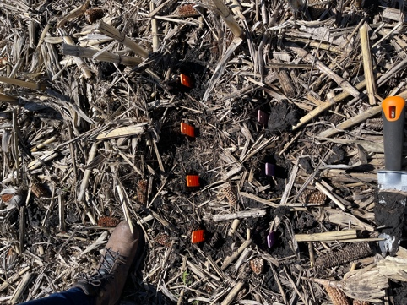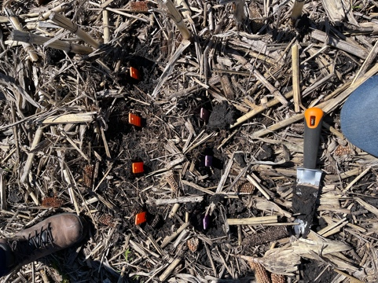
PRSTM probes for measuring soil nutrient dynamics on situ.

Root Sampling
At the stages V2 and R1, a linear foot-long sample of soybean was taken from the 2nd row of 24 different plots across the two drainage variables and the three tillage treatments in every repetition (8 repetitions total). Plants were washed and stored at +4 °C until processing. Roots were oven-dried at 60 °C for more than 48 h, and weighed to calculate dry weight biomass. Roots were scanned using the program RhizoVision Explorer v2.0.3 (Seethepalli and York, 2020) using algorithms described by Seethepalli et al. (2021).

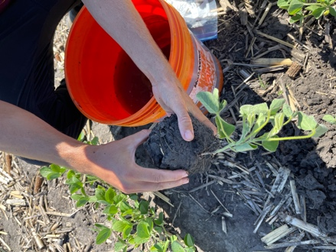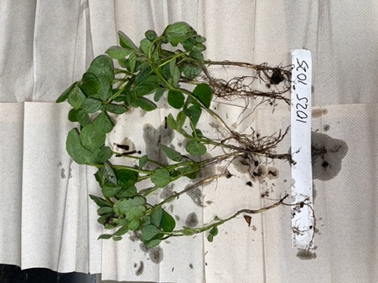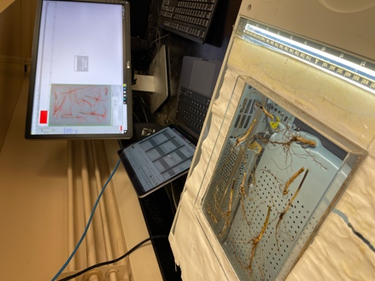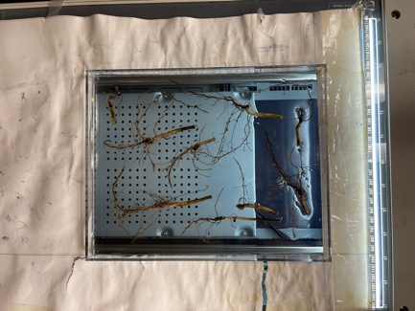
Preparation of root samples for scanning using the program RhizoVision Explorer.

Bulk density
Measurements of soil bulk density are frequently used as an input parameter for models that forecast soil dynamics. When aggregating soil data, such models frequently use bulk density measurements to account for horizon mass. For this unique measurement, the variables taken into account are drainage and tillage (24 plots total), at a depth of 6” and at field moisture content to oven-dried bulk density, at the stage R3.

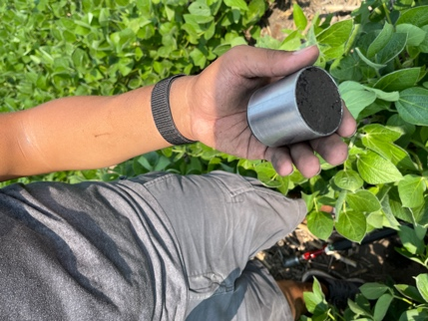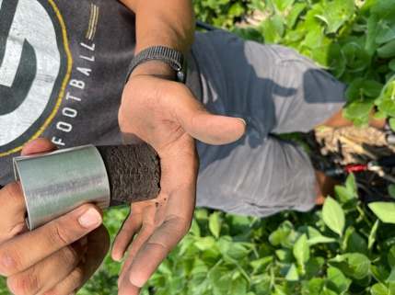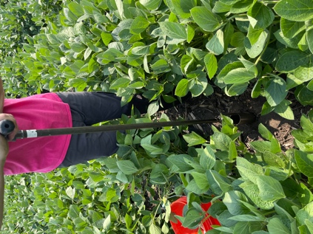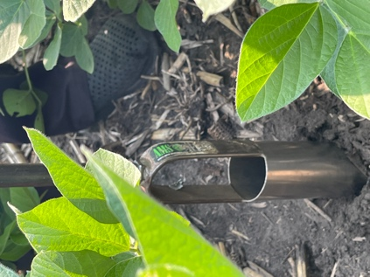
Soil sampling for bulk density in plots under
different drainage and tillage conditions.

Soil infiltration
Water on the soil surface enters the soil profile through a process known as infiltration. It relates to groundwater and overland flow, dictating the percentage of irrigation or rainwater that penetrates the soil and, consequently, influencing the quantity of runoff that causes future soil erosion. The soil infiltration method used was the single ring, which usually uses one ring of 30 cm in diameter and 20 cm in height. Two single measurements (both extremes of the middle rows) were performed per plot, with a total of 24 plots across the drainage and tillage variables, at the stage R3.
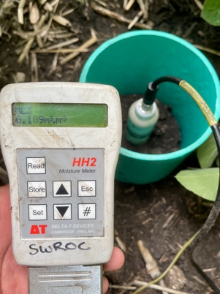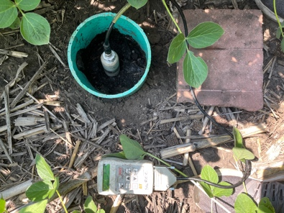
Measurement of soil infiltration at the two extremes of the soybean plot
between the second and third rows.

Multispectral Imaginary – Drone
The process of gathering data that provides insight into crop health and vegetation management is consolidated through the use of multispectral imagery. Agricultural drones with multispectral imaging camera sensors help farmers manage crops, soil, fertilizing, and irrigation more efficiently. One of the most often used vegetation indicators is the Normalized Difference Vegetation Index (NDVI), which measures the "greenness" or photosynthetic activity of plants. Based on the finding that various surfaces reflect various types of light differently, vegetation indexes were developed.

Particularly photosynthesis-active plants absorb the majority of the red light that strikes it while largely reflecting the near infrared light. In contrast to healthy vegetation, stressed or dying vegetation reflects more red light. Likewise, the reflection of light over non-vegetated surfaces is substantially more uniform.

During the 2022 summer season, drone flights weekly are performed at the site to keep up with the development of the canopy for both crops, corn and soybean.

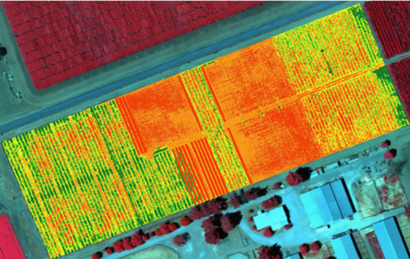
Image taken from the Drone Academy website for illustration purposes only (https://abjacademy.global/wp-content/uploads/2018/03/multi.png)

Summary of activities to perform at the Drainage Site
during the 2022 summer season

