Project Title: 2022 Weed Control and Plant Health Multi-Company Demonstration
Private Investigator (P.I.): Next Gen Ag, LLC/Andrew Lueck
Quarter Report: #1 May 2022 thru July 2022
Objectives: (List project objectives as submitted in final proposal. Describe activity for each during this reporting period.)
- Involve 8 different industry partners with 10 treatment entries each;
  - Goal #1: Modify Treatments to 160 Strips for Demos (Done)
  - Goal #2: Industry partners contribute chemistry [BASF, Bayer, Corteva, FMC, Max Systems, Syngenta, Valent, Winfield] (Done).
  - Goal #3: Industry partners attend and present at plot tour [BASF, Bayer, Corteva, FMC, Max Systems, Syngenta, Valent, Winfield] (Done).
- Facilitate a successful physical and virtual tour to support information transfer;
  - Goal #1: Field tour held August 11th (Done).
  - Goal #2: Virtual tour to develop in November (Not Done).
  - Goal #3: Collect data to contribute to tours (80% Done).
- Develop proof of concept for annual multi-industry field and virtual demonstration event that;
  - Provides equal opportunity to industry partners to display products (seed and chemical)
  - Build the reputation of MSRPC and Next Gen Ag LLC
  - Provide the farmers an opportunity to learn in a way that best suits them with options of a physical tour, publication review, or virtual tour accessed online
Achievements: (Specific project achievements during this reporting period.)
- Trials was successfully planted.
- Every plot was planted and sprayed according to plans, NO MISTAKES!
- 14, 28, 42, and 56 DAA waterhemp control notes taken.
- 19 field day attendees. 10 surveys taken; “Quality of tour” was rated 4.30/5.00; “Transfer of Info” rated 4.6/5.00; 10/10 would return for another tour next year however 3 individuals wonder if field tours are the “way” anymore….want to see the virtual tour concept; Survey participants wanted to see more plant health and possible corn demos in the future.
- All 8 industry partners were on site to present and a LOT of great conversation and networking!
Challenges: (Challenges encountered. Specific request for assistance from Production AT on any challenges listed above.)
- Erratic weed emergence due to new established trial area.
- Less representation of farmers then expected at tour (6).
- Less representation of local co-op staff then expected at plot tour (none).
- Really need additional support and resources to be provided by the MSRPC board in the future for promotion. May consider moving away from field days or abandoning the work altogether in 2023…..will depend on virtual tour outcome.

Publications/Symposium:
- All publications incomplete and will be included in the Quarter 2 report as separate attachments.
- Plot tours complete with 19 attendees; virtual tour concept and impact TBD.
- Publications posted to Next Gen Ag website that can be accessed through or FB page “Next Gen Ag LLC” in Quarter #2.
Tech Transfer: (General audience identification and approximate number attending.)
- Plot tour attendees 19.
- Facebook page followers 123; posts have reached up to 1,200 individuals.
- Anticipate ag expo this winter.
- Virtual tour build and dispersion via social media this winter.
Image 1. Large Industry Trial Renville, MN.
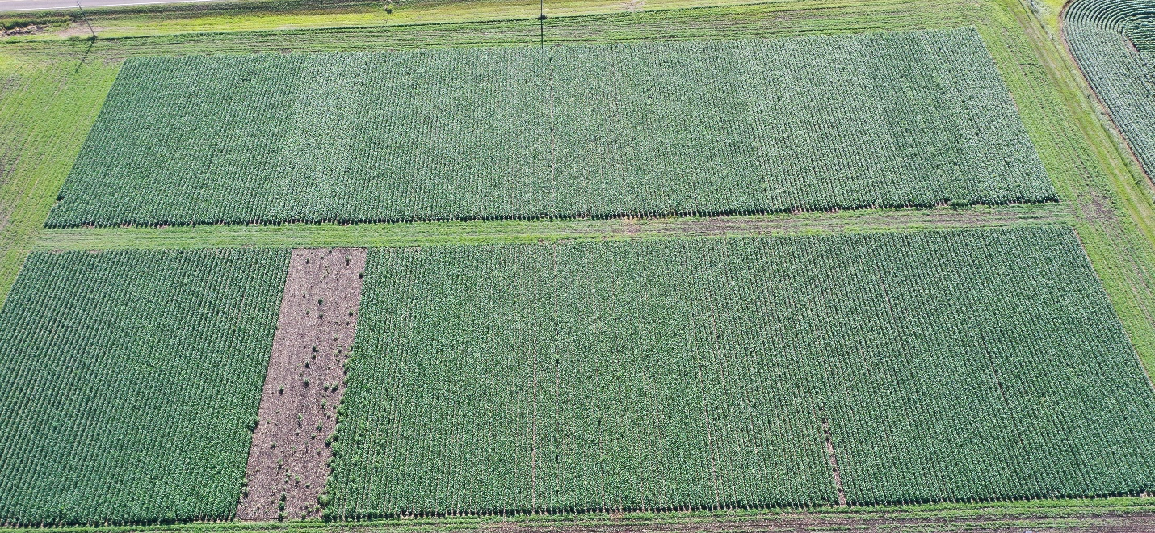

Image 2. Varietal Crop Safety Trial.
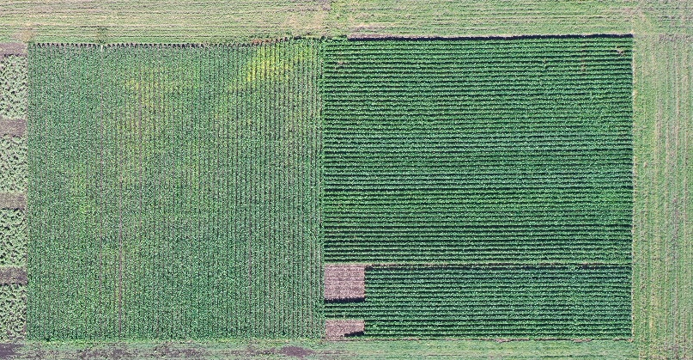

Image 3. PRE Vs. PRE fb EPOST Micro-Rate Comginations.
